**ACKNOWLEDGEMENT**

First, Alhamdulillah, who has blessed us with the knowledge and ability to progress in our graduation project. We want to express our sincere appreciation to our supervisor Dr. Mona Ali for her support, full of useful ideas and constant encouragement, which played a great role in our successful passing of the fourth stage of the project. We are also extremely thankful to Dr. Noor Hafsa for her valuable suggestions and valuable time to shape and enhance the quality of our work. Finally, it is our pleasure to thank all the members of the team who have made their contribution and worked so hard to achieve this result.

**UNDERTAKING**

This is to declare that the project entitled “Quality Monitoring System for Reusing AC Water” is an original work done by undersigned, in partial fulfillment of the requirements for the degree “Bachelor of Computer Science” at Computer Science Department, College of Computer Sciences and Information Technology, King Faisal University.

All the analysis, design and system development have been accomplished by the undersigned. Moreover, this project has not been submitted to any other college or university.

|  |  |
| --- | --- |
| Ghzayel Alhajri |  |
| Donia Alzahrani |  |
| Noura Almarri | صورة تحتوي على رسم, خط يد, الخط, فن الخط  تم إنشاء الوصف تلقائياً |
| Rawan Alomair |  |

**ABSTRACT**

In regions with hot climates such as Saudi Arabia, air conditioning systems are indispensable, yet they produce large amounts of condensate water that often goes to waste. This project addresses the growing need for sustainable water resources by developing a smart system that repurposes air conditioning condensate for agricultural irrigation. The proposed solution integrates a sensor-based IoT system with machine learning algorithms to monitor and assess water quality in real time. Key water parameters—pH, temperature, turbidity, and total dissolved solids—are measured and transmitted to a cloud-based server where a Support Vector Machine (SVM) model classifies the water as suitable or unsuitable for irrigation. A web-based dashboard presents real-time data and alerts users when water quality falls outside safe thresholds. The system promotes sustainable practices by transforming waste into a valuable resource, reducing dependence on freshwater, and supporting environmental goals such as afforestation. Evaluations showed a classification accuracy of over 98% with justifications, demonstrating the feasibility and effectiveness of using AC condensate as an alternative water source for agriculture

Table of Contents

List of Figures viii

List of Tables ix

1 Introduction 1

1.1 Background 2

1.2 Motivation 2

1.3 Problem statement 3

2 Innovation and utility of this project 3

3 Scope and degree of the challenge 4

3.1 Objectives 5

4 Comprehensive analysis of related work 6

4.1 IoT-Based Water Quality Monitoring Systems 6

4.2 Sensor Integration for Agricultural Water Monitoring 6

4.3 reuse of air conditioning (AC) water and Social Acceptance 7

4.4 Condensed Water Recycling in an Air Conditioning Unit 8

4.5 heavy Metals and Microbial Assessment of Air Conditioning Condensate Water in Jeddah 8

4.6 Recover Condensate Water from Air Conditioners in Palestine 9

4.7 Comparison 10

4.8 Summary 11

5 Methodology 12

5.1 Work Methodology: 12

5.2 System methodology 13

6 Identification of Alternative Solutions/Approaches and Justification of Selecting a Solution/Approach 15

6.1 Alternative Solutions for Water Source Type in Agriculture 15

6.2 Alternative Solutions for Application Types in Water Management 16

6.3 Alternative solutions for Methods for Collecting Water: 17

6.4 Alternative solutions for Methods for Measuring Water Quality: 17

6.5 Alternative solutions for Algorithms for Optimization: 18

6.6 Alternative solutions for Classification Algorithms: 19

7 Detailed Project Requirements 21

7.1 Functional Requirements 21

7.1.1 User Requirements 21

7.1.2 System Requirements 21

7.2 Non-functional Requirements 22

7.3 Hardware Requirements 22

8 Discussion of tools and techniques used during project proposal 24

9 Appropriate analysis 25

9.1 Database Dictionary 25

9.2 irrigation water standards 26

9.3 Context diagram 27

9.4 Use case diagram 28

9.5 Activity diagram 29

9.6 Architecture diagrams 30

10 Description of tools and techniques to be used during project implementation 31

11 Details of Project Implementation Conforming to the Project Proposal 33

11.1 Hardware Acquisition and Connection 33

11.2 Creating Dataset and Labeling 33

11.3 Building the Machine Learning Model 35

11.4 Validation with different methods 36

11.5 Model integration: 36

11.6 Website Development 38

12 Mastery of Tools and Techniques Used in Project Implementation 38

12.1 Hardware Implementation and Connection 38

12.2 Hardware Connection 39

12.3 Software Tools 40

12.4 Commands and Code snippets: 41

12.4.1 Wi-Fi Credential Storage in EEPROM 41

12.4.2 Sensor's measurement functions 42

12.4.3 Sensor Data Packaging and Sending to Flask 42

12.4.4 SVM 43

12.4.5 Flask Server Endpoint to Receive and Classify Data 44

12.4.6 Storing Classified Results to Firebase 44

13 Overall Project Outcomes/Achievements 45

13.1 Model Suitability 45

13.2 Selection of Cloud Storage 45

13.3 Web application functionality 46

13.4 Justification Of Classification Outcomes: 48

14 Analysis Of Overall Result Through Comparison, Validation or Verification 49

14.1 Performance Evaluation 49

14.2 Overfitting Concerns 49

14.3 Cross-Validation and Confusion Matrix Insights 49

14.4 Metrics 50

14.5 Confusion matrix: 51

14.6 Cloud Storage and System Optimization 53

14.7 Website testing results 54

15 Comprehensive Remarks on Overall Project Outcomes and Achievements 57

15.1 Conclusion 57

15.2 Future Work 58

References 59

appendix A 61

# List of Figures

Figure ‎4‑1: the hardware experimental set up of smart water quality monitoring system 6

Figure ‎4‑2: "Illustration of the amount of condensate water produced by air conditioning systems, highlighting potential water reuse opportunities." 9

Figure ‎5‑1: "Agile model for project management, demonstrating iterative development and feedback loops to enhance project outcomes." 12

Figure ‎5‑2: Flow diagram of the system workflow, outlining the process from water collection to quality assessment and user notification." 14

Figure ‎7‑1: pH sensor 23

Figure ‎7‑2:TDS sensor 23

Figure ‎7‑3: Turbidity sensor 23

Figure ‎7‑4: Temperature sensor 23

Figure ‎9‑1: "Context diagram illustrating the system components and their interactions for the water quality monitoring system." 27

Figure ‎9‑2:"Use case diagram depicting user interactions and functionalities within the water quality monitoring application." 28

Figure ‎9‑3: "Activity diagram representing the steps and processes involved in monitoring water quality using the proposed system." 29

Figure ‎9‑4: "Architecture diagram detailing the structural design and integration of components in the water quality monitoring system." 30

Figure ‎10‑1: pH sensor 31

Figure ‎10‑2: TDS sensor 31

Figure ‎10‑3: Turbidity sensor 31

Figure ‎10‑4: Temperature sensor 31

Figure 11‑1:Dataset collected from sensors 35

Figure 11‑2:classification report of SVM model 36

Figure 11‑3:workflow of the implementation 37

Figure 12‑1: diagram of the hardware connection 40

Figure 12‑2: hardware connection 40

Figure12‑3: Sensor readings code snippet 42

Figure ‎13‑4: Data sending code snippet 42

Figure ‎13‑5: SVM module code snippet 43

Figure ‎13‑6: flask route code snippet 44

Figure ‎13‑7: Data storage to firebase code snippet 44

Figure ‎15‑5: Justification example 48

Figure ‎15‑1: SVM confusion matrix 52

Figure ‎15‑2: Decision tree confusion matrix 52

Figure ‎15‑3: Random Forest confusion matrix 52

Figure ‎15‑4: Logistic regression confusion matrix 52

Figure ‎14‑1:suitable water with acceptable parameters 54

Figure ‎14‑2:High pH resulting to classify it as unsuitable 55

Figure ‎14‑3:TDS resulting in classifying it as unsuitable 56

# List of Tables

Table ‎4‑1: Decision support on water quality for each sample based on pH, temperature, ORP, and EC. Three membership functions (MFs) such as Not Acceptable (NA), Adequate (ADE), and Highly Acceptable (HACC) are applied. 7

Table ‎4‑2: Decision support in terms of Not Acceptable (NA), Adequate (ADE), and Highly Acceptable (HACC) on overall water quality for each sample. 7

Table ‎4‑3: Comparison of related work. 11

Table ‎6‑1 Advantage and this advantage of alternative solution for Water Source Type in Agriculture: 16

Table ‎6‑2: Advantage and this advantage of alternative solution for Application Types in Water Management 16

Table ‎6‑3: Advantage and this advantage of alternative solution for Methods for Collecting Water 17

Table ‎6‑4: Advantage and this advantage of alternative solution for Methods for Measuring Water Quality 18

Table ‎6‑5: Advantage and this advantage of alternative solution for Algorithms for Optimization 19

Table ‎6‑6: Advantage and this advantage of alternative solution for Classification Algorithms 20

Table ‎7‑1:Hardware requirements for the system, listing various sensors used for measuring factors like pH, turbidity, contamination, and total dissolved solids (TDS) to support plant growth. 23

Table ‎8‑1: tools and techniques used during project proposal 24

Table ‎9‑1: database table 25

Table ‎9‑2: irrigation water standards 26

Table ‎10‑1: tools and techniques to be used during implementation 33

Table 14‑‑1: module comparison 50

Table 14‑‑2: K-fold validation 51

Table 14‑‎‑3: Confusion matrix for multiple modules comparaison 52

Table 14‑‎‑4:cloud storage comparison 53

Table ‎14‑5: Test case1 54

Table ‎14‑6: Test case 2 55

Table ‎14‑7: Test case 3 56

# Introduction

With the increased use of air conditioners and the rising global water shortage problem, the traditional and expensive methods for resource securement must be rethought. Modern algorithms and smart sensors are powerful tools capable of massively assisting in making the world a better place. Despite being a scarce resource itself, water supports many ecosystems, not to mention the human and agricultural activities that rely on this precious resource. It is common that air conditioners, for example, generate condensate water to bring needed cooling, this water then becomes waste. Yet, this water can be used as a possible alternative for several purposes, including agricultural irrigation. This system is a must for the safe reuse of condensate water. Built with smart sensors, the system tracks essential water quality parameters and analyses in real time over a wireless data connection. Powered by advanced algorithms and machine learning models, the system predicts changes in water quality and type leading to alerts when safe levels are exceeded informing users if they should or should not use it to water their plants.

**The Roadmap for This Document Is as Follows:**

1. **Title Page, Abstract, and Table of Contents** – Introduce the project and structure.
2. **Introduction** – Outline background, motivation, and problem statement.
3. **Main Body** – Includes innovation, objectives, related work, methodology, and tools.
4. **Implementation and Outcomes** – Covers system development, key achievements, and classification logic.
5. **Analysis and Validation** – Presents performance evaluation and testing results.
6. **Conclusion and Future Work** – Highlight key achievements and possible improvements.
7. **References** – Cited sources in APA format.
8. **Appendix** – Contains supporting material (survey results summary).

## Background

In many parts of the world, especially the regions experiencing higher temperatures, air conditioning is an everyday necessity. It takes the heat and provides cooling but then it produces condensate water that is usually treated as a waste. Yet this water is an extremely precious resource if appropriately managed. It can be used as an alternate source of supply for irrigation, and other non-traditional uses. As it has been estimated on a typical day the average global water realistic consumption is around 175 liters per person per day (Crouch, Jacobs, & Speight, 2021) [1]. Reusing condensate can be seen as a major potential approach, offering an entirely new way of solving our scarcity in water and the lack of green spaces. Its quality is often uncertain, and if not monitored it could become a health risk, but it can be used for sustainable, water-saving habits by recycling the same water for irrigation to promote the green initiative especially in regions like GCC.

## Motivation

One of the biggest contributing factors is the need for more water resources especially in hot-climate arid regions (mainly GCC) that lack natural freshwater sources and where air conditioners are powered continuously for months, spurred by rising population and rapid urbanization alongside climate change impacts. With the pressure of depending on water desalination in GCC, it is important to identify and harness alternative water resources. The energy demand of the desalination process is considered to be high and that resulted in a significant need to find other methods to mitigate the negative impact on the environment by the existing desalination plants (Moossa, Trivedi, Saleem, & Zaidi, 2022) [2]. These issues can be significantly decreased by utilizing condensate water generated by air conditioning units to encourage water conservation, afforestation, and advance sustainable practices that are advantageous for the natural environment as these countries seek to promote (KSA 2030 vision).

## Problem Statement

This project aims to bridge the gap between waste and resource by developing an integrated **Air Conditioning Water Quality Monitoring System**. This system will incorporate advanced sensors to measure key water quality parameters, coupled with machine learning algorithms to assess and predict the water's suitability for irrigation. A web-based application will provide users with real-time data, enabling informed decisions about water reuse in agriculture. By addressing these research gaps, the project not only promotes sustainable water management practices but also enhances agricultural productivity, particularly in arid regions.

# Innovation And Utility of This Project

The "Water Reusing System" developed where state-of-the-art algorithms are proposed for real-time assessment of quality of condensate water which fed into a system of sensors that check vital parameters wirelessly, making sure the water is safe to reuse for irrigation. Through machine learning, the system provides real-time feedback and can predict water quality tendencies helping to act in advance. If safety thresholds are exceeded, the operational alert triggers will be sent out providing users greater confidence in utilizing repurposed water.

This project is useful for changing condensate water from a waste product to an abundance of living water which can be used for irrigation needs. This ensures all the water flowing is safe and allows users of the system to have transparency and control over how their water will be used so that water supplies do not get wasted. The data can support local water management practices and thereby promote a culture of sustainability and resilience in communities affected by insufficient water. The effort not only meets immediate water needs but also benefits in the long term local and regional environmental objectives and afforestation.

# Scope And Degree of Challenge

The aim of this project is to design a "Water Reusing System" using condensate water from air conditioning units in effective style for agriculture. With the use of advanced algorithms, this system will be able to monitor and analyze vital water quality metrics continuously. The monitoring will start once the condensate is collected to provide real-time information on its suitability for irrigation. The key to the project is a series of advanced data algorithms that observe sensor readings being transmitted wirelessly back to a cloud-based server to process. By using machine learning methods, the system recognizes patterns in monitored datasets which can be used for increasing predictive accuracy using historical readings from databases. This past data learning will enable the system to predict quality issues and send alarms as soon as possible. The system will automatically send notifications to the application interface when water quality parameters breached the safety thresholds. It is hard to make sure that the algorithms can accurately understand data for a broad spectrum of conditions, and it is important to create models that are built off historical data and information to work well for continuous improvement. There is also an obvious engineering challenge to integrate seamless data flow between collection, algorithmic analysis, user notifications and educational contents.

The objectives of the system include promoting water conservation by reusing condensate water, enhancing the sustainability of this often-wasted resource for agriculture, and reducing irrigation costs for farmers. The system aims to support urban greening initiatives and improve quality of life and environmental health. To achieve these objectives, it will incorporate advanced algorithms and smart sensors that wirelessly transmit vital water quality data to a cloud-based platform. Machine learning techniques will predict quality issues and allow for alerts when safety thresholds are exceeded. However, there are constraints to consider. The system must operate efficiently within the existing infrastructure of air conditioning units and agricultural setups. It also needs to comply with health and safety regulations regarding water reuse. Furthermore, the system should be user-friendly, enabling individuals without extensive technical knowledge to operate it effectively.

The goal of this project is to convert this largely wasted byproduct “condensate water” into a valuable resource that can be implemented using scientific algorithms, historical data analytics, and educational rules for sustainable water management for agriculture in regions with wide usage of air conditioning units.

## Objectives

1. Water Conservation: Reducing water waste by reusing condensate water from air conditioning systems, as it helps alleviate water scarcity in dry areas or limited water supplies in some areas.
2. Sustainability and Resource Efficiency: Promote sustainability by contributing to the sustainable use of water and utilizing commonly wasted resources (AC condensate) for agricultural purposes, reducing the demand for and conserving fresh water used for irrigation.
3. Cost Reduction: Reduce agricultural irrigation costs and conserve natural resources by supplementing or replacing conventional water with free and readily available air conditioning water.
4. Urban Greening and Food Security: Supporting urban agriculture and gardens improves the quality of life, as greenery has a calming and reassuring effect on people in general, and it enhances human health and mental safety. The idea of ​​afforestation and its dimension is very important, not only the environmental dimension, but also the tourism dimension, and this falls under the Green Saudi Arabia project, as it is about benefiting from unused resources, and this applies to air conditioning water, not the process of putting pressure on existing resources.

# Comprehensive Analysis of Related Work

## IoT-Based Water Quality Monitoring Systems

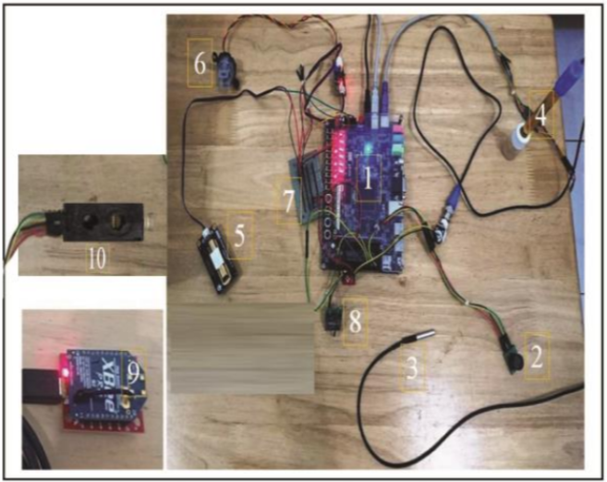In this article titled “IOT Based Water Quality Monitoring System”, Konde & Deosarkar (2020) [3] propose an efficient approach to enhancing the process of remote water quality monitoring using the IoT system for real-time data processing. It monitors six water parameters: pH, turbidity, humidity, water level, temperature, and carbon dioxide (CO2). The main structural component of the system is a field-programmable gate array (FPGA) board and wireless communication with the help of Zigbee modules. The sensor nodes, installed on the bank of the monitored water body, collect data and transmit it to the FPGA board, which processes the information using a Nio’s II processor. The results of sensor data are then transmitted wirelessly to another device through the Zigbee module, as illustrated in Figure 1.

Figure ‑: the hardware experimental set up of smart water quality monitoring system

## Sensor Integration for Agricultural Water Monitoring

The article “Integration of Sensing Framework with a Decision Support System for Monitoring Water Quality in Agriculture” by (Zainurin et al., 2023) [4] Shows a water quality monitoring system designed for agricultural use. The system consists of multiple sensors including PH, electrical conductivity (EC), temperature, and oxidation-reduction potential (ORP). It also utilizes decision making which applies the concept of fuzzy logic. An Arduino is used to process data from sensors. At the same time, the software designed in Python evaluates the water quality for irrigation and classifies it into three categories: unacceptable (NA), adequate (ADE), and highly acceptable (HACC) as detailed in Table 1. The system is tested on rivers, lakes, tap water, and filtered water. More importantly, it shows that by using this technology, farmers can assess the quality of water they are using in real-time, use water efficiently as well as minimize incidences of crop diseases emanating from the utilization of water that is contaminated, particularly in regions where water quality constitutes a major concern in the cultivation of crops, as summarized in Table 2.

|  |  |  |  |  |
| --- | --- | --- | --- | --- |
| **Decision on Water Quality** | | | | |
| **Water Samples** | **PH** | **Temperature** | **ORP** | **EC** |
| Filtered water | HACC | HACC | HACC | HACC |
| Tap water | HACC | HACC | ADE | HACC |
| River water | NA | HACC | HACC | HACC |
| Lake water | HACC | HACC | ADE | NA |

Table ‑: Decision support on water quality for each sample based on pH, temperature, ORP, and EC. Three membership functions (MFs) such as Not Acceptable (NA), Adequate (ADE), and Highly Acceptable (HACC) are applied.

|  |  |
| --- | --- |
| **Water Samples** | **Overall Decision on Water Quality** |
| Filtered water | HACC |
| Tap water | ADE |
| River water | NA |
| Lake water | NA |

Table ‑: Decision support in terms of Not Acceptable (NA), Adequate (ADE), and Highly Acceptable (HACC) on overall water quality for each sample.

## Reuse of Air Conditioning (AC) Water and Social Acceptance

The article “Assessing Water Production from Air Conditioning Systems as an Unconventional Supply Source” by (Matarneh et al., 2024) [5] explores the possibility of using air conditioner condensate water as an alternative source of water supply that is usually disposed of through sewage, as it showed excellent quality that meets the standards of drinking and irrigation water in Jordan. The study evaluated the physical and chemical properties of condensate water. It also explores the potential of reusing this water through a survey of university employees on the aspect of social acceptance since factors like gender and age influence the social acceptance of water. In this paper, it is concluded that informing the populace on the problem and developing a responsible attitude towards the usage of water can enhance the populace’s acceptance of non-conventional water sources.

## Condensed Water Recycling in an Air Conditioning Unit

In the article titled “Condensed Water Recycling in an Air Conditioning Unit,” Abdullah and Mursalin (2021) [6] propose an effective method for reusing condensate water produced by air conditioning systems. The study analyzes water parameters such as pH, turbidity, total dissolved solids (TDS), electrical conductivity, chemical oxygen demand (COD), biological oxygen demand (BOD), and heavy metals like copper, lead, and manganese. Water properties were determined using techniques aligned with e Indian Standard for Methods of Sampling and Test the physical and chemical for Water (IS-3025 (2003)). The highlighted uses include industrial applications and irrigation, toilet flushing, laundry, and radiator cooling. After such treatment, condensate water was determined to be safe for human consumption and therefore could offer a sustainable source of water in the future.

## Heavy Metals and Microbial Assessment of Air Conditioning Condensate Water in Jeddah

In the article titled “Heavy Metals and Microbial Assessment of Air Conditioning Condensate Water in Jeddah City-Saudi Arabia: Concept of Sustainable Water Resources,” Alghamdi et al. (2024) [7] examine the potential of reusing air conditioning (AC) condensate water for sustainable water resource management. The primary application focused on determining the quality of condensate water for household and agricultural purposes. The study revealed that water produced from split and window air conditioners met irrigation water quality standards, and those from split produced a larger amount every year, as illustrated in Figure 2. Thus, this innovative technique may help to surmount the problems connected with water shortages in arid territories, including Saudi Arabia, at reasonable costs and with minimal impact on the environment. The study monitored key water parameters, including pH, turbidity, total dissolved solids (TDS), electrical conductivity (EC), chemical oxygen demand (COD), and heavy metal concentrations. Microbial analysis detected bacterial presence in a small number of samples and all bacteria detected were non-hazardous. The technology employed included laboratory spectrophotometers for chemical analysis and inductively coupled plasma optical emission spectroscopy (ICP-OES) for heavy metal quantification. Microbial identification was conducted using conventional culture methods and DNA sequencing for phylogenetic analysis. Data analysis was supported by statistical tools such as SPSS.

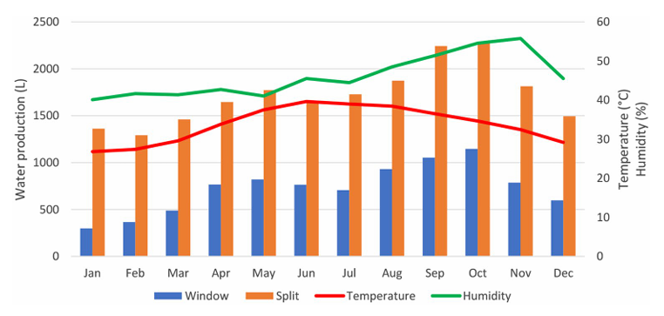

Figure ‑: "Illustration of the amount of condensate water produced by air conditioning systems, highlighting potential water reuse opportunities."

## Recover Condensate Water from Air Conditioners in Palestine

In the article titled *“Developing a Strategy to Recover Condensate Water from Air Conditioners in Palestine”* Siam et al. (2019) [8] explore the potential of utilizing condensate water as an alternative resource for addressing water scarcity in Palestine. The study monitored water quality parameters such as pH, total dissolved solids (TDS), electrical conductivity (EC), dissolved oxygen (DO), turbidity, chemical oxygen demand (COD), biological oxygen demand (BOD), and heavy metals like copper, manganese, and iron. While most parameters met Palestinian standards for reused irrigation water. However, for drinking water standards some samples had high COD, BOD, and turbidity values. Analytical examinations were made by Inductively Coupled Plasma-Optical Emission Spectrometry (ICP-OES), as well as field measurements of physical features. Actual condensate water recovery was estimated in Ramallah and Jericho with actual fresh water ranging from 8.63L to 15.1L per air conditioning unit. This water was considered suitable for use in areas such as irrigation and cleaning. The authors emphasize the need for public awareness campaigns and structured strategies to encourage the collection and reuse of this underutilized resource, supporting sustainable water management practices in the region.

## Comparison

|  |  |  |  |  |  |
| --- | --- | --- | --- | --- | --- |
| **Criteria**  **Project** | **Water Parameters Monitored** | **Applied for Agriculture** | **Air Conditioning**  **Water** | **User-Friendly Interface** | **Decision Support System** |
| **IoT-Based Water Quality Monitoring System** | pH, turbidity, humidity, water level, temperature, CO2 | No | No | No | No |
| **Sensor Integration for Agricultural Water Monitoring** | pH, EC, temperature, ORP | Yes | No | No | Yes |
| **Reuse of Air Conditioning (AC) Water and Social Acceptance** | Physical and chemical properties | Yes | Yes | No | No |
| **heavy Metals and Microbial Assessment of Air Conditioning Condensate Water in Jeddah** | pH, turbidity, TDS, EC, COD, and heavy metal concentrations, Microbial analysis | Yes | Yes | No | No |
| **Condensed Water Recycling in an Air Conditioning Unit** | pH, turbidity, TDS, EC, TSS, BOD, COD, alkalinity, chloride content, concentrations of copper, lead, iron, manganese | Yes | Yes | No | No |
| **Recover Condensate Water from Air Conditioners in Palestine** | pH, TDS, EC, DO, turbidity, COD, BOD, and heavy metals | Yes | Yes | No | No |
| **Reusing air conditioning water for agriculture (purposed project)** | pH, TDS, Turbidity, Temperature | Yes | Yes | Yes | Yes |

Table ‑: Comparison of related work.

## Summary

From this comparison between related research and our project on recycling air conditioner water for agriculture, our project stands out by incorporating smart sensors that measure water quality parameters and provide highly accurate results. In addition to the sensor network, the system includes a mobile application for easy monitoring and control. Using this app, people can monitor water quality information through their devices and get notification if there exists any pollutant present in the water body so that the water supply can be handled effectively. Moreover, the system provides educational guidelines based on sensor readings. What sets our project apart is the combination of real-time monitoring, user-friendly interface, and educational components, all aimed at promoting sustainable water reuse for agriculture while ensuring the health and productivity of crops.

# Methodology

## Work Methodology:

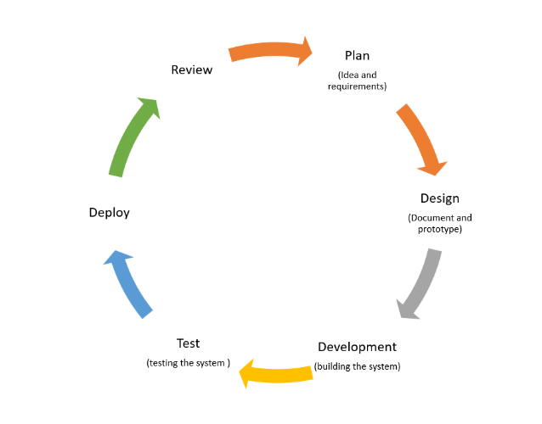

Figure ‑: "Agile model for project management, demonstrating iterative development and feedback loops to enhance project outcomes."

In order to achieve the "Reusing Air Conditioning Water for Agriculture" project we decided to choose the Agile methodology as shown in figure 5-1. Agile's flexibility, feedback loops, and emphasis on quality assurance make it an iterative and adaptable method that guarantees greater control over the project. Continuous improvement and prompt problem-solving during project phases are made possible by this method. Small sprints make it possible to do evaluations on a regular basis, guaranteeing that the project's goals are effectively achieved while preserving its high standard of quality.

## System Methodology

Our system methodology is evolving into robust and automated architecture, shown in Figure 5-2, and involves multiple coordinated components that ensure accurate classification of water quality and real-time decision-making. The system is now designed to operate as an integrated IoT-cloud solution with a web-based backend, enabling users to monitor water quality continuously and remotely. The process begins with the ESP32 microcontroller, which collects real-time data from four connected sensors: temperature (DS18B20), turbidity, pH, and TDS. These sensors are installed to monitor key water quality parameters. The ESP32 reads data at predefined intervals and stores Wi-Fi credentials in EEPROM for persistent connectivity. Once the data is gathered, the ESP32 formats the readings into JSON and transmits them via HTTP POST to a Flask server hosted on Render.com. The Flask server is equipped with a pre-trained Support Vector Machine (SVM) machine learning model and a data scaler. Upon receiving data, the server preprocesses it using the scaler, runs it through the model, and classifies the water as either suitable or unsuitable for agricultural use and shows it on the website.

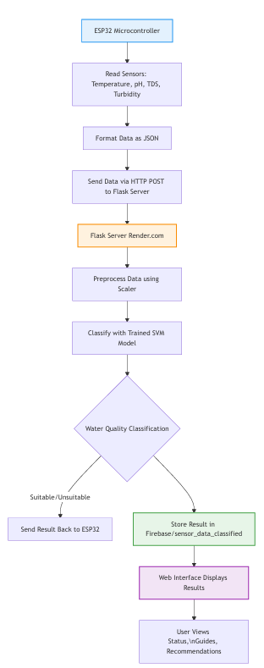

Figure ‑: Flow diagram of the system workflow, outlining the process from water collection to quality assessment and user notification."

**5.3 Project Expected Outcomes**

We are expecting from the proposed project **"Reusing Air Conditioning Water for Agriculture":**

1. **Development of a Comprehensive AC Water Quality Monitoring System:** This includes sensors to measure parameters such as pH, turbidity, temperature, and total dissolved solids.
2. **User-Friendly Web Application:** The application will allow users to access real-time data, receive notifications regarding water quality, and provide educational resources on best practices for water reuse in agriculture.
3. **Enhanced Decision-Making Tools:** The system will offer analytics and predictive insights using machine learning models, helping users determine when and how to use condensate water for irrigation effectively.
4. **Promoting Sustainable Practices:** By demonstrating the feasibility of reusing condensate water, the project aims to foster greater acceptance and implementation of water conservation strategies in agricultural practices.

# Identification of Alternative Solutions/Approaches and Justification of Selecting a Solution/Approach

## Alternative Solutions for Water Source Type in Agriculture

When selecting an alternative water source for agricultural irrigation, various options must be considered. Here are some potential alternatives to using air conditioning water:

|  |  |  |
| --- | --- | --- |
| Alternative solution | Advantages | Disadvantages |
| Condensate Water from Air Conditioning Units | • readily available • Reduces dependency on municipal water | •inconsistent • Requires storage infrastructure |
| Greywater Recycling | • Reduces water waste by reusing household water • Provides a steady supply | • Needs treatment before use • May not be suitable for all crops due to contaminants |
| Desalination | • Abundant supply in coastal areas • Can provide fresh water in arid regions | • High energy cost • Expensive technology • Environmental impact on marine life |
| Treated Wastewater (Effluent) | • Reuses water from sewage systems • Provides large volumes of water | • Requires advanced treatment • Possible health concerns if not treated properly |
| Groundwater Extraction | • Available in many regions • Reliable in the short term | • Risk of over-extraction • Can deplete aquifers and lead to land subsidence |

Table ‑ Advantage and this advantage of alternative solution for Water Source Type in Agriculture:

**Selected Solution: Condensate Water from Air Conditioning Units**

**Justification:** This non-traditional source is readily available and can be effectively repurposed for irrigation, helping to alleviate water scarcity.

## Alternative Solutions for Application Types in Water Management

In the context of managing and monitoring water reuse systems, various types of applications can be developed to control and optimize water usage in agriculture. The choice of application type depends on factors like accessibility, scalability, and user requirements.

|  |  |  |
| --- | --- | --- |
| Alternative Solution | Advantages | Disadvantages |
| Desktop Application | • Higher processing power for complex calculations • Can handle large datasets | • Limited accessibility • Requires a dedicated device |
| Mobile Application | • High accessibility • Easy to use in the field • Portability | • Limited processing power • Smaller screen size may limit usability |
| Web Application | • Accessible from any device with internet • Easy to update and maintain | • Requires internet connection • Security vulnerabilities in web platforms |

Table ‑: Advantage and this advantage of alternative solution for Application Types in Water Management

**Selected Solution: Web Application**

**Justification:** A web application provides easy access for users to monitor water quality in real-time from any device.

## Alternative Solutions for Methods for Collecting Water:

To successfully implement the *"Reusing Air Conditioning Water for Agriculture"* project, it is essential to compare different methods for collecting water and assessing its quality, as well as evaluating algorithms that can optimize system performance.

|  |  |  |  |
| --- | --- | --- | --- |
| **Disadvantages** | **Advantages** | **Description** | **Method** |
| Limited capacity; potential for contamination. | Simple and cost-effective. | Gathering water from the existing drip tray of the air conditioner and directing it to a reservoir. | Direct Collection via Drip Tray |
| Requires installation and maintenance. | Increased efficiency and capacity. | Water from the coil by installing a special collector beneath the air conditioner. | Custom Condensate Collector |
| Complex setup; requires piping infrastructure. | Scalable for large operations. | Gathering water into a common tank from several air conditioners. | Centralized Collection System |

Table ‑: Advantage and this advantage of alternative solution for Methods for Collecting Water

**Selected Solution: Centralized Collection System**

**Justification:** efficiently gathers water from multiple units, maximizing availability for large-scale agriculture, despite complexity and contamination risks.

## Alternative Solutions for Methods for Measuring Water Quality:

This table presents the advantages and disadvantages of several water quality measurement techniques, offering information on their applicability, accuracy, cost, and practicality. Every technique has special characteristics that make it appropriate for particular use cases, such rapid manual testing, in-depth laboratory analysis, or real-time monitoring.

|  |  |  |  |
| --- | --- | --- | --- |
| **Disadvantages** | **Advantages** | **Description** | **Method** |
| Higher upfront cost. | Real-time monitoring; integration with IoT. | To regularly check quality, digital conductivity, pH, and mineral sensors should be installed. | **Digital Sensors** |
| Time-consuming; not practical for regular use. | High accuracy and comprehensive results. | sample collection and delivery to a laboratory for in-depth examination. | **Lab Analysis** |
| Limited precision; not automated. | Low cost and easy to use. | Performing a manual water quality assessment using portable kits or pH strips. | **Manual Testing (Kits)** |

Table ‑: Advantage and this advantage of alternative solution for Methods for Measuring Water Quality

**Selected Solution: Digital Sensors**

**Justification:** Digital sensors provide precise and reliable measurements of water quality parameters, enabling accurate monitoring for agricultural use.

## Alternative Solutions for Algorithms for Optimization:

The algorithms used to optimize water resource management, including irrigation and consumption planning, are compared in this table. It highlights each method's usefulness for various situations while outlining its advantages, disadvantages, and distinctive features. Based on variables including adaptability, computing demands, and the intricacy of the optimization problem, the comparison aids in determining the best method.

|  |  |  |  |
| --- | --- | --- | --- |
| **Disadvantages** | **Advantages** | **Description** | **Method** |
| Requires a large dataset and computational power. | Highly adaptable and accurate. | uses both historical data and real-time inputs to forecast water consumption. | **Machine Learning Models** |
| Lacks adaptability to changing conditions. | Simple to implement; reliable. | uses irrigation automation based on pre-established thresholds (such as soil moisture levels). | **Rule-Based Algorithm** |
| Computationally intensive; requires tuning. | Effective for complex systems. | optimizes resource allocation and watering schedules | **Genetic Algorithms** |
| Can be complex to design. | Flexible and intuitive. | manages inaccurate and unpredictable data (such as fluctuating water quality levels) in order to make decisions. | **Fuzzy Logic Algorithm** |

Table ‑: Advantage and this advantage of alternative solution for Algorithms for Optimization

**Selected Solution: Machine Learning Algorithms**

**Justification:** These algorithms can analyze historical data to predict future water quality trends, enhancing decision-making.

## Alternative Solutions for Classification Algorithms:

The advantages, disadvantages, and best applications of several categorization algorithms are listed in this table. It offers guidance for choosing the best algorithm depending on the needs of the problem and the properties of the dataset. Accuracy, computational efficiency, interpretability, and the algorithm's capacity to manage complicated or high-dimensional data are all taken into account in the comparison.

|  |  |  |  |
| --- | --- | --- | --- |
| **Algorithm** | **Strengths** | **Weaknesses** | **Best Use Cases** |
| Random Forest | High accuracy because of ensemble learning; resilience to overfitting; and ability to deal with missing data. | computationally demanding; less interpretable than a single tree. | With complex datasets, greater accuracy is needed. |
| Decision Trees | Both numerical and categorical data are handled with ease of interpretation and visualization. | prone to overfitting, which pruning can help with; less resilient to noise. | Quick insights and easy classification tasks. |
| Logistic Regression | Simple and computationally efficient. Interpretable coefficients. | Assumes that features and output are linear; may have trouble with data that is not linearly separable. | Binary outcomes. Quick baseline models. |
| Support Vector Machines (SVM) | It is efficient in high-dimensional spaces and performs well on small datasets. | Sensitive to kernel and parameter selection. Challenges when dealing with big datasets. | Binary classification. High-dimensional data. |

Table ‑: Advantage and this advantage of alternative solution for Classification Algorithms

**Selected Solution: Support Vector Machine (SVM)**

**Justification:** SVM effectively classifies complex datasets, making it suitable for determining the suitability of water for irrigation.

# Detailed Project Requirements

## Functional Requirements

### User Requirements

Users should be able to operate the device without extensive technical knowledge. The system should provide user friendly interface that shows information relevant to the user in an easy-to-understand way. Users want the option to access the system remotely via a mobile app or web interface. It should give a clear statement as to whether the water could be used for plants and show pH level and extra information and a way to export the data should be provided in formats like CSV or PDF. Users need the ability to set preferences for plant types and watering schedules. Users require access to comprehensive support and user manuals for troubleshooting and guidance.

### System Requirements

* The device must collect water from the air conditioning unit efficiently.
* The device should include sensors to measure different factors that affect plant growth. It should monitor water quality parameters (pH, turbidity, etc.) and notify users if levels are outside acceptable ranges.
* The system should include algorithms to determine the suitability of water for specific plants based on their needs.
* The system should recommend adjustments (e.g., filtration, treatment) if the water quality is not suitable.
* The device also should have a system for delivering water to the plants.
* The device must operate using a reliable energy source, possibly integrating solar power as an option.
* The device should have clear visual indicators (e.g., LEDs) to show operational status
* There should be a simple interface to help users recycle water and use it to grow plants effectively.

## Non-functional Requirements

1. **Performance**:

The system should analyze water quality in real-time with a response time of less than 5 seconds.

1. **Availability**:

The system must have an up-time of 99.5% to ensure consistent monitoring.

1. **Scalability**:

The system should be scalable to accommodate multiple air conditioning units and plant types.

1. **Usability**:

The user interface should be intuitive and require minimal training for effective use.

1. **Security**:

The system must protect user data and ensure secure access, especially for online components.

1. **Portability**:

The system should be portable or easy to install in various places.

1. **Maintainability**:

The system should be designed for easy maintenance and updates, with clear documentation for troubleshooting.

1. **Environmental Considerations**:

The system must operate efficiently to minimize energy consumption and waste.

## Hardware Requirements

The system should have various sensors for measuring aspects that can affect plant growth such as pH, turbidity, contamination, total dissolved solids (TDS). This table shows possible sensors to use.

|  |  |  |
| --- | --- | --- |
| Name of the sensor | How the sensor work | Image |
| pH Sensor | Measures acidity or alkalinity of the water, crucial for plant health. | Figure ‑: pH sensor  Grove - PH Sensor Kit (E-201C-Blue) This is a pH sensor that decides whether the water is more acidic or alkaline.[9] |
| TDS Sensor (Total Dissolved Solids) | Indicates the total amount of dissolved substances in the water. | Figure ‑:TDS sensor  KS0429 keyestudio TDS Meter V1.0 This sensor can find the total dissolved solids like salt, metal and minerals using electrical conductivity.[10] |
| Turbidity Sensor | Measures water clarity, which helps identify contaminants. | Figure ‑: Turbidity sensor  TS-300B This sensor can measure the level of turbidity in water.[11] |
| Temperature Sensor | Monitors water temperature, important for both plant growth and sensor performance. | Banggood - Waterproof Temperature Sensor DS18B20 Probe  Figure ‑: Temperature sensor  DS18B20 Digital Temperature Sensor This is a waterproof temperature sensor.[12] |

Table ‑:Hardware requirements for the system, listing various sensors used for measuring factors like pH, turbidity, contamination, and total dissolved solids (TDS) to support plant growth.

As well as a network unit for sending results to an external database and calculating results through artificial intelligence. A control unit to manage the sensors and pump operation. The design should accommodate water transport to plants without having to reorganize all the plumping. A pump could be needed to facilitate the movement of water to the plants. A wireless power source should be provided for convenience such as batteries or solar panels.

# Discussion of Tools and Techniques Used During Project Proposal

|  |  |
| --- | --- |
| Tool/Technique | Description of Tool/Technique |
| Microsoft Word Logo - PNG and Vector - Logo DownloadMicrosoft Office Word | Microsoft Office Word is software that helps in creating, editing, styling, and saving documents. It is used in projects to write and format reports. |
| PowerPoint Logo Icon (2024) - Free Download PNG, SVG, AIMicrosoft Office PowerPoint | Microsoft Office PowerPoint is software used to create slideshow presentations. It is used in projects to present milestones. |
| Google ScholarGoogle Scholar Logo PNG vector in SVG, PDF, AI, CDR format | Google Scholar is a web search engine for scholarly literature, journal articles, and books. It is used in projects to gather reliable references. |
| Google Drive | Google Drive is a cloud storage platform that allows users to store and share files. It is used to collaborate and share files between team members. |
| Draw.io Logo PNG Vector (SVG) Free DownloadDraw,io | Draw.io is an online tool for creating diagrams, flowcharts, and UML diagrams. It is used in projects to visualize diagram. |
| Grammarly ‪Why Grammarly is a must have tool for Businesses and Website SEO?‬‏ | Grammarly is an online platform for checking grammar, spelling, and writing style. It helps ensure the accuracy of project reports. |
| OneDrive Microsoft OneDrive · Activepieces | OneDrive is a cloud storage service from Microsoft that enables file sharing and collaboration. It is used to store and access files securely. |
|  | Microsoft Teams is a communication platform that facilitates meetings and collaboration. It was used in our project for team meetings and discussions with the supervisor. |

Table ‑: tools and techniques used during project proposal

# Appropriate Analysis

In this section, we will go through comprehensive analysis of the system's processes and storage with diagrams that illustrate the proposed system design: Context diagram, Use Case diagram, Activity diagram, and Architecture design.

## Database Dictionary

This sub-section describes the structure of the Firebase Realtime Database node used to store water quality measurements. The database follows a document-oriented, NoSQL approach where each record is stored as a JSON object. Each record includes attributes for measurement parameters and a suitability flag.

Table ‑: database table

|  |  |  |  |  |
| --- | --- | --- | --- | --- |
| Attribute Name | Data type | Data Size | Constraints | Description |
| ID | INT | 4 bytes | PRIMARY_KEY, AUTO_INCREMENT | Unique identifier for each record |
| TDS | FLOAT | 4 bytes | NOT NULL | Measures the combined content of all inorganic and organic substances in a liquid. |
| Temperature | FLOAT | 4 bytes | NOT NULL | It indicates the heat level of the water, which can affect various chemical and biological processes. |
| Turbidity | FLOAT | 4 bytes | NOT NULL | Measures the clarity of the water, with higher values indicating more suspended particles. |
| pH | FLOAT | 4 bytes | NOT NULL | Indicates the acidity or alkalinity of the water, essential for determining its suitability for agriculture. |
| fit_for_agriculture | BOOLEAN | 1 byte | NOT NULL | A boolean value that determines whether the water is suitable for agricultural use based on the readings of the other parameters. |

## Irrigation Water Standards

In Saudi Arabia, there are national and international standards [13][14] that have been developed to regulate water quality used for irrigation to encourage safe practices in agriculture, to maintain the quality of the soil and human health since the food produced affects our general health. These standards address parameters, including pH, turbidity, Total Dissolved Solids, and temperature:

|  |  |
| --- | --- |
| **Parameters** | **Recommended Range/Limit** |
| pH | 6.5-8.5 |
| turbidity | <=5 NTU |
| Total Dissolved Solids | <=1000 mg/L |
| temperature | 10°C–25°C |

Table ‑: irrigation water standards

**Impact on Irrigation:**

1. **pH**

* Affects nutrient availability and solubility.
* Extreme pH values (<6.0 or >9.0) can harm plants and soil structure.
* Slight adjustments may be required for certain crops or soil.

1. **Turbidity**

* High turbidity means particles which may interfere with proper flow and may clog irrigation systems.
* Excessive turbidity can reduce sunlight penetration and interfere with plant growth.

1. **Total Dissolved Solids**

* High TDS levels indicate salinity, which can impair plant water uptake and reduce crop yield.

1. **temperature**

* Affects the solubility of oxygen and nutrient availability.
* Extreme temperatures (>35°C or <5°C) can stress plants and reduce microbial activity in the soil.

## Context Diagram

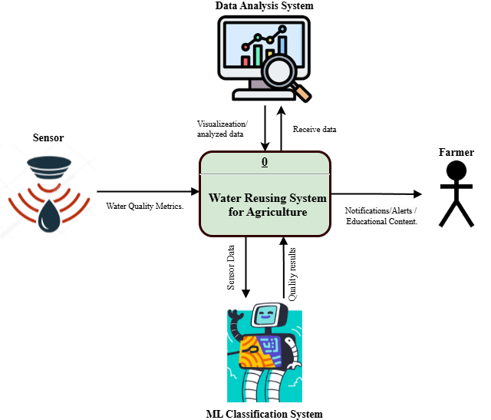

Figure ‑: "Context diagram illustrating the system components and their interactions for the water quality monitoring system."

The context diagram illustrates the components and their interactions in figure 9-1. The system serves as the main hub that links and makes it easier for various entities to share data. In order to continuously gather environmental water quality measures and send this data to the system, sensors are essential. In order to classify the water quality in real-time, the system then interacts with the ML classification component, which processes the raw sensor data. This classified data is sent back to the main system for additional examination. The Data Analysis System then takes over, transforming the processed data into a readable and useful format through interpretation and visualization. In order to engage with the system, farmers, who are the end users, receive alerts and information about the quality of the water as well as educational materials that are intended to assist them in making wise water use decisions. The smooth information flow between these interrelated parts is shown by the arrows in the diagram.

## Use Case Diagram

Figure 9-2 shows the user case for the for the Reusing air conditioning water for agriculture.

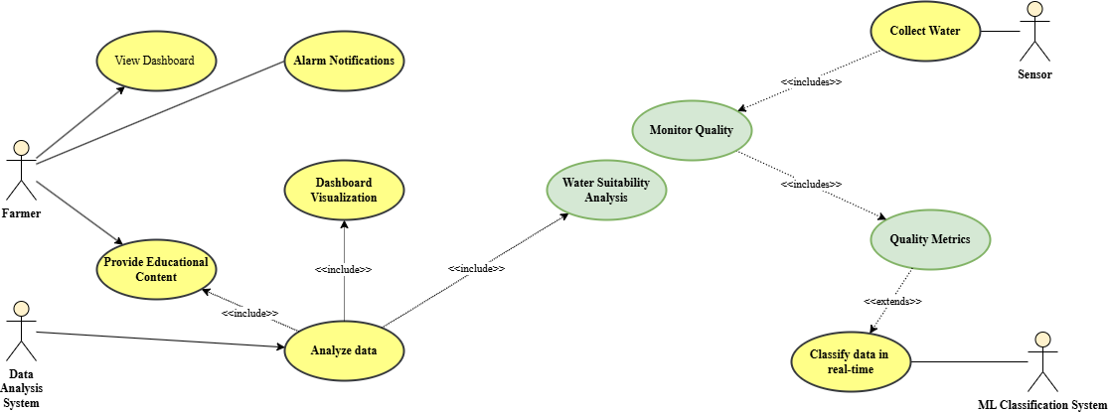

Figure ‑:"Use case diagram depicting user interactions and functionalities within the water quality monitoring application."

The use case diagram explores the roles and relationships between users in the system in further detail. Farmers are depicted as engaged users who keep an eye on the system's results via the dashboard. In addition to using alert notifications to keep them updated on important water quality concerns, they can gain from instructional materials that improve their comprehension of water management techniques. Farmers can engage with an easy-to-use and educational dashboard thanks to the Data Analysis System's processing and visualization of the incoming data. Conversely, the ML system and sensors serve as the foundation of the technological procedure, collaborating to gather and categorize water data in real-time. The diagram's usage of "include" links highlights how these tasks are interconnected and shows how each component advances the goal of data analysis and actionable insights.

## Activity Diagram

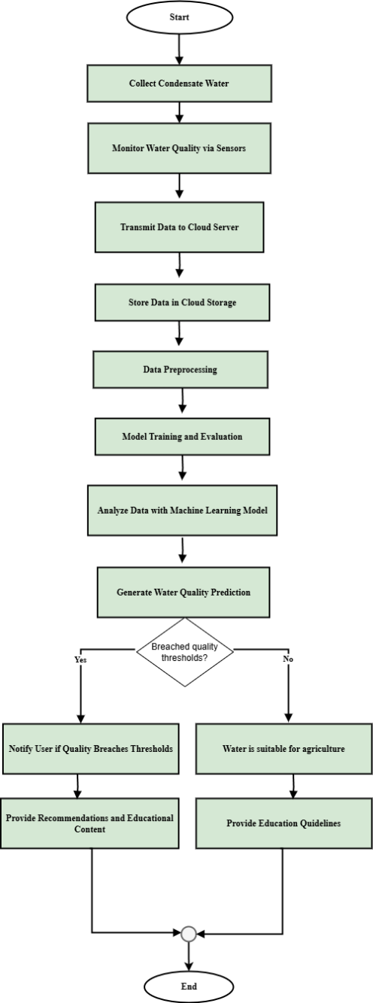

Figure ‑: "Activity diagram representing the steps and processes involved in monitoring water quality using the proposed system."

The activity diagram in figure 9-3 illustrates the process flow of the system from start to end. The first step in the procedure is gathering condensate water and using sensors to check its quality. For storage and further data preparation, the gathered data is sent to the cloud. After that, the system analyzes the data and creates predictions about the quality of the water by training and assessing machine learning models. The system alerts the user, makes suggestions, and presents instructional materials if the water quality is above predetermined level. The user is given instructions to determine if the water quality is appropriate for farming. After sending the proper notices or suggestions, the procedure is over.

## Architecture Diagrams

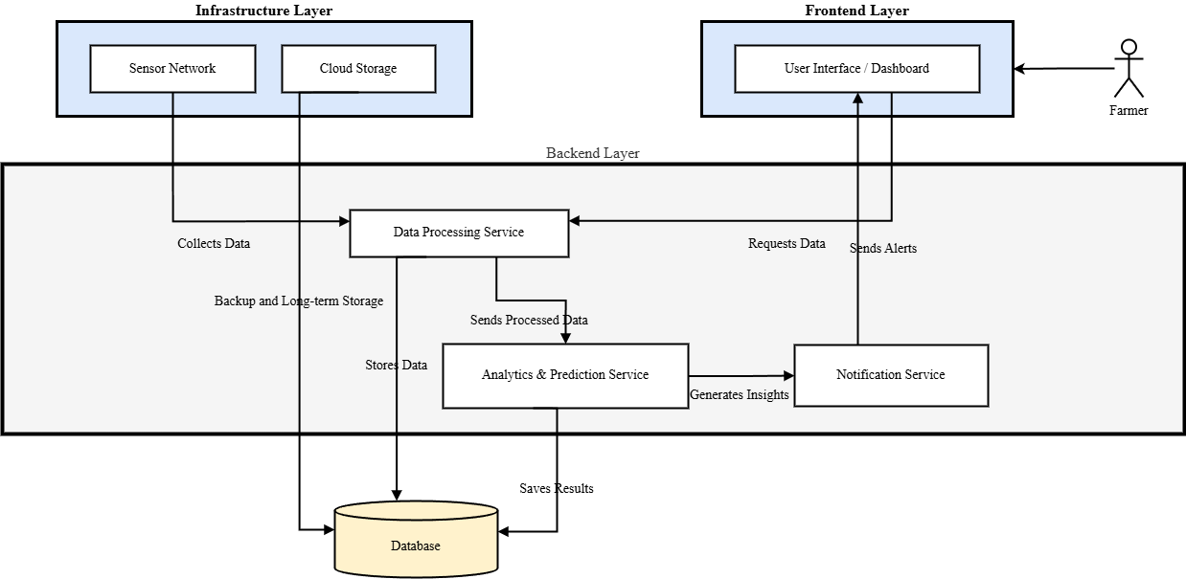

Figure ‑: "Architecture diagram detailing the structural design and integration of components in the water quality monitoring system."

The architecture diagram in figure 9-4 illustrates a system designed to monitor and analyze water quality for agricultural purposes. The system functions through three interrelated layers, each of which is essential to its smooth operation. Located at the base is the infrastructure layer, which contains the sensor network in charge of gathering environmental data on water quality. Assuring secure transmission and dependable long-term storage for later use, these sensors continuously track a number of characteristics and send the data to cloud storage. The backend layer, which serves as the brain of the system, builds upon this foundation. The data processing service in this tier collects the unprocessed sensor data, transforms it into a format that can be used, and safely stores it in the database. The analytics and prediction service then uses the stored data to analyze trends and produce insightful information about water quality using sophisticated machine learning algorithms. The notification service then receives these insights, guaranteeing that users are swiftly informed of any problems or developments pertaining to the quality of the water. The frontend layer is at the top of the system, where farmers can access the system directly through the dashboard and user interface. By means of this interface, farmers can effortlessly obtain comprehensive insights into water quality and obtain prompt notifications, empowering them to make well-informed choices to maximize farming methods. These layers work together to form a unified and effective system that empowers farmers and raises agricultural output.

# Description of Tools and Techniques to Be Used During Project Implementation

|  |  |  |  |  |  |  |  |  |
| --- | --- | --- | --- | --- | --- | --- | --- | --- |
| Sensors | | | | | | | | |
| Figure ‑: pH sensor  Grove - PH Sensor Kit (E-201C-Blue) | | TDS Sensor  A circuit board with wires  Description automatically generated  Figure ‑: TDS sensor  KS0429 keyestudio TDS Meter V1.0 | | Turbidity Sensor    Figure ‑: Turbidity sensor  TS-300B | | | Temperature Sensor  Banggood - Waterproof Temperature Sensor DS18B20 Probe  Figure ‑: Temperature sensor  DS18B20 Digital Temperature Sensor | |
| **Description**: Measures the acidity or alkalinity of water. The pH scale ranges from 0 to 14, with 7 being neutral.  **Functionality**: Essential for determining whether the condensate water is suitable for irrigation, as extreme pH levels can harm plants | **Description**: Measures the concentration of dissolved solids in water, expressed in parts per million (ppm).  **Functionality**: High TDS levels can indicate the presence of salts, minerals, or pollutants, affecting water quality for irrigation. It's an important parameter for ensuring water safety for plants. | | **Description**: Measures the cloudiness of water caused by particles. High turbidity can indicate contamination.  **Functionality**: Helps assess the cleanliness of condensate water, which is crucial for irrigation. | | | **Description**: Measures the water temperature, affecting oxygen solubility and plant metabolic rates.  **Functionality**: Provides context for other water quality measurements. | | |
| Microcontroller | | | | | | | | |
| ESP32  هاي ليتجو لوحة تطوير ESP-WROOM-32 ESP32 ESP-32S 2.4GHz ثنائي الوضع واي فاي  + معالج وحدة تحكم دقيقة ثنائي النواة مدمج مع هوائي RF مرشح AMP AP STA  لاردوينو IDE: اشتري اون لاين | | | | | | | | |
| **Description**: A low-cost, low-power microcontroller with built-in Wi-Fi and Bluetooth capabilities, suitable for IoT applications and wireless data communication.  **Functionality**: it can collect data from sensors, connect to the internet for remote monitoring, and control devices wirelessly. | | | | | | | | |
| Data Storage | | | | | | | | |
| JSON | | | | | CSV File | | | |
| ‪Json file - Free interface icons‬‏ | | | | How to convert PDF to CSV: 5 easy steps | Adobe Acrobat | | | | |
| **Description**: A lightweight data-interchange format that is easy for humans to read and write, and easy for machines to parse and generate.  **Functionality**: it stores structured data in key-value pairs and is commonly used for data exchange between devices or applications. | | | | **Description**: A comma-separated values file that stores tabular data in plain text format.  **Functionality**: Simple to implement and easy to read, making it a good option for initial data logging. | | | | |
| Firebase | | | | | | | | |
| ‪Firebase logo - Social media & Logos Icons‬‏ | | | | | | | | |
| **Description**: A cloud-based platform by Google that provides real-time database services, authentication, and cloud storage for web and mobile applications.  **Functionality**: it stores and syncs data in real-time across connected devices and supports secure, scalable data handling. | | | | | | | | |
| Programming Language | | | | | | | | |
| Python logo and symbol, meaning, history, PNG | | | | A versatile programming language. Use libraries like pandas for data manipulation and sqlite3 for database interaction, and for writing rules and conditions for the alerts system | | | | |
| Model Learning and Training Techniques | | | | | | | | |
| **Libraries:**  like **scikit-learn**, **TensorFlow**, or **Keras** for implementing machine learning algorithms. | | | **Classification Algorithms:**  such as:  **Support Vector Machines (SVM):**  Effective for high-dimensional data classification. | | | | | **Training and Model Evaluation:**  - ﻿﻿ Split the dataset into training and testing sets  ﻿﻿- Train the model using the training data (safe or unsafe for irrigation).  - Use metrics such as accuracy, precision, recall, and F1-score to evaluate the model's performance on the testing set. |
| User Interface (Web Page Development Technologies) | | | | | | | | |
| **HTML, CSS, and JavaScript**  to create a web interface.  **frameworks: Flask (for Python)**  to easily serve data.  **Display Features**  real-time updates of sensor readings, visualizations, and indicators showing whether the water is suitable for plants | | | | | | | | |

Table ‑: tools and techniques to be used during implementation

# Details of Project Implementation Conforming to the Project Proposal

This section describes the implementation details of the water quality monitoring system, focusing on the aspects completed during the implementation phase.

## Hardware Acquisition and Connection

The first step involved acquiring the necessary hardware components, including sensors for measuring water quality parameters (temperature, TDS, pH, turbidity), an ESP32 microcontroller for data acquisition, and jumper wires for connecting the components. The sensors were connected to the ESP32 using a solderless breadboard, ensuring stable connections and facilitating data transmission.

## Creating Dataset and Labeling

To develop and evaluate the system, a dataset was created by collecting air conditioning water samples and recording their sensor readings. Additional samples were generated to expand the dataset and improve model robustness. The dataset includes variations in water quality parameters and consists of 2605 records, after the additional data generation it became 5931. This dataset ensures that the machine learning model can effectively distinguish between suitable and unsuitable water for irrigation.

**Dataset Split:**

* Training Set Size**:** 4744 samples (80% of the data)
* Testing Set Size**:** 1187 samples (20% of the data)

**Data Characteristics:**

* The features used are temp_sensor, tds_sensor, ph_sensor, and turbidity_sensor. These features represent key parameters for water quality assessment as shown in figure 11-1.
* The label is fit_or_unfit, indicating whether the water sample is suitable or unsuitable for irrigation after its classified through the model.

**Additional Data Generation Process:**

To enrich the dataset and ensure sufficient representation of both water quality classes, additional samples were generated through controlled environmental manipulation. This was done physically using the sensor setup, rather than synthetic data generation.

The following parameters were adjusted:

• **pH**: Altered by introducing calibrated acidic or basic substances to simulate different pH levels.

• **Temperature**: Raised or lowered within safe limits to reflect environmental variation.

• **Turbidity:** Modified by adding suspended particles to simulate various pollution levels.

• **TDS (Total Dissolved Solids):** Adjusted by dissolving controlled amounts of salts /minerals.

These controlled changes allowed the creation of a more diverse and realistic dataset, which supported the machine learning model’s ability to generalize across real-world agricultural water conditions.

**Dataset Distribution:**

To ensure model performance is not biased toward overrepresented classes. The dataset used in this study includes 2,605 samples labeled under the binary class fit_or_unfit, where:

• Class 1 (fit): 3,344 samples (≈56.4%)

• Class 0 (unfit): 2,587 samples (≈43.6%)

While this reflects a relatively balanced dataset, the slight imbalance was accounted for during the model evaluation phase. Specifically, stratified k-fold cross-validation was applied to preserve class proportions in each fold, reducing the risk of biased training or evaluation. Both standard and stratified cross-validation yielded consistent high accuracy, averaging 98.7%, confirming that the model could generalize well across both classes.

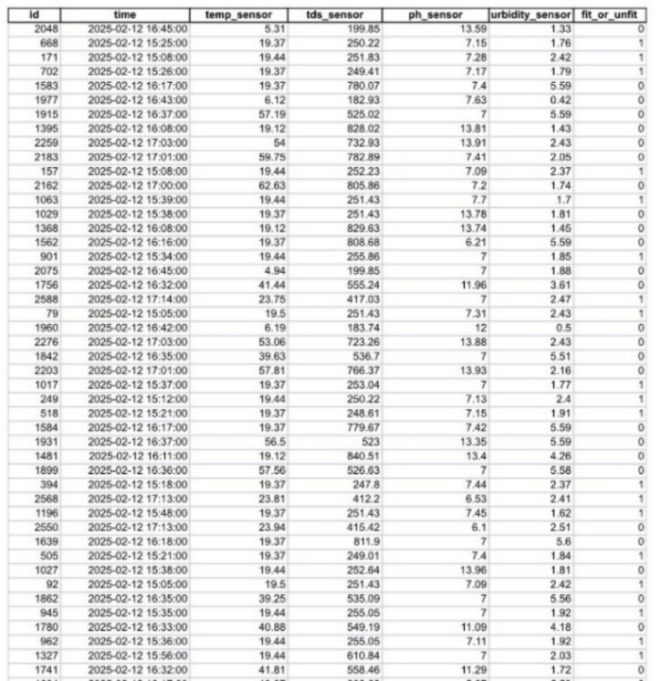

Figure 11‑1:Dataset collected from sensors

## Building the Machine Learning Model

In the early stages of model training, the Random Forest algorithm was initially chosen due to its high potential. However, after testing, it was observed that the model was overfitting—performing well on the training data but not as effectively on the unseen test data. To address this issue, a Support Vector Machine (SVM) model was selected. The Support Vector Machine (SVM) is a supervised learning algorithm used for classification and regression, particularly in high-dimensional and binary tasks. It finds the optimal hyperplane to separate data points while maximizing the margin between support vectors. If the data is not linearly separable, SVM applies the "kernel trick" to transform it into a higher-dimensional space using functions such as linear, polynomial, RBF, and sigmoid. When perfect separation is not possible, a soft margin allows some misclassifications to improve generalization. SVM demonstrated better performance in this case, achieving 98% accuracy as shown in figure 11-2. This improvement was crucial as it indicated that SVM could generalize well with unseen data. Feature scaling was applied to ensure no single feature dominated the model training. Scaling parameters were exported alongside the 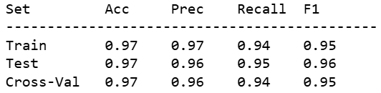model as a .skl file for consistent scaling during deployment.

Figure 11‑2:classification report of SVM model

## Validation With Different Methods

The first validation technique used was 5-fold cross-validation, where the model was trained and evaluated on different subsets of the data. The cross-validation scores were consistently high with 98.2% and an overall mean accuracy of 98.7%. This indicates that the model is not overfitting and can generalize well to unseen data. The cross-validation scores are indicative of the model’s robustness, as it maintains high accuracy across multiple splits of the dataset. In addition to standard cross-validation, stratified cross-validation was also performed to ensure that each fold maintained the same proportion of target class distributions. This method proved to be equally effective, with stratified cross-validation scores also averaging at 98.7%. This consistent performance between the two cross-validation methods reinforces the model’s stability, even when accounting for potential class imbalance.

## Model Integration:

The system was designed to collect and analyze real-time water quality data using an ESP32 microcontroller, a Flask server, and a cloud-based database. The ESP32 reads data from multiple sensors—temperature (DS18B20), pH, TDS, and turbidity—and sends the readings in JSON format via HTTP POST requests to a Flask application hosted on Render.com. The Flask server loads a pre-trained SVM machine learning model along with a scaler to classify the water quality as either suitable or unsuitable. After classification, the results along with the original sensor readings are stored in Firebase Realtime Database under the path /sensor_data_classified. This setup enables fast, reliable storage and retrieval of data for further analysis or visualization. The system workflow, as shown in Figure 11-3, follows these steps:

1. Sensor Data Reading: The ESP32 reads water quality data from connected sensors periodically.
2. Classification: The Flask server applies to the SVM model to classify the water quality.
3. Saving Results: Classified results and their corresponding data are stored in Firebase.
4. Display Results: Stored data can be accessed and displayed through a user interface for monitoring.

This architecture ensures a scalable and intelligent solution for real-time water quality monitoring, integrating IoT, machine learning, and cloud technologies seamlessly. 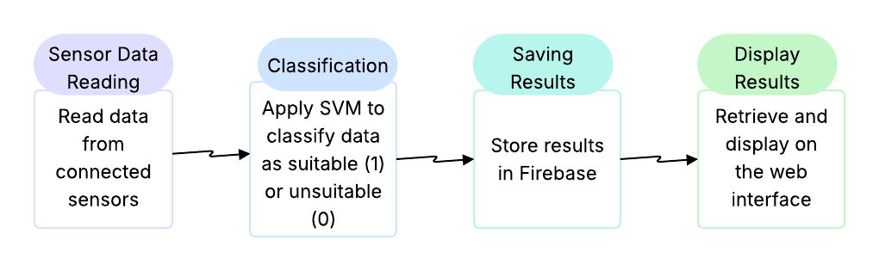

Figure 11‑3:workflow of the implementation

## Website Development

A web-based dashboard was created using HTML, CSS, and PHP to present real-time sensor readings and classification outcomes. The dashboard offers a structured representation of the collected data, allowing users to efficiently monitor water quality parameters.

# Mastery of Tools and Techniques Used in Project Implementation

This part discusses the tools and techniques utilized in the implementation of the system, emphasizing the major components and processes taken to meld both hardware and software factors.

## Hardware Implementation and Connection

The ESP32 microcontroller was selected for its ability to handle sensor data and integrate multiple components. The setup involved powering the ESP32 and establishing connections with the sensors responsible for monitoring water quality.

The system includes the following hardware:

* **TDS Sensor Module**: This sensor measured the Total Dissolved Solids (TDS) in the water, which was essential for determining the water quality for irrigation purposes.
* **Turbidity Sensor**: This sensor evaluated the clarity of the water by detecting the amount of light scattered by suspended particles, which was vital for assessing the water quality.
* **DS18B20 Temperature Sensor**: This digital sensor measured the water temperature accurately, which was critical for maintaining optimal conditions for plant growth.
* **pH Sensor**: This sensor was instrumental in measuring the pH level of the water, an important variable for ensuring that the water quality was suitable for agricultural use.
* **Jumper Wires (Male to Male & Female to Male)**: These wires facilitated connections between sensors, the ESP32, and the breadboard, allowing for easy assembly of the circuit without soldering.
* **Solderless Breadboard**: A breadboard was used to securely and temporarily assemble the circuit components, making it easier to test and modify during development.

We used jumper cables to connect these sensors to the ESP32 and put them on a solderless breadboard so that the electrical connections can be stable and data transmission can happen well. Sensor readings were again used; this time ran through an SVM model to classify the water quality. If the gathered water passes the predefined status of safety, the irrigation marks are enabled. Otherwise, it is deemed unsuitable in the system.

## Hardware Connection

The system includes four main sensors connected to the ESP32 microcontroller using a solderless breadboard and jumper wires. Each sensor features three common connection points: **VCC (Power)**, **GND (Ground)**, and **DATA (Signal)**. Here's how each one is connected:

First, we have a breadboard where we connected the ESP32 module. We took the GND pin from the ESP32 and connected it to the entire negative rail on the breadboard, and the 3.3V pin was connected to the entire positive rail.

Then we started working with the four sensors. Each sensor has three wires:

**•** **The GND wire** is connected to the same negative rail where we connected the ESP32 ground.

**•** **The VCC wire** is connected to the same positive rail as the ESP32 3.3V, to provide power to the sensor.

**•** **The last wire** is the data wire, which is used to send data. Each sensor’s data wire is connected to a specific pin on the ESP32, as defined in the Arduino code.

Finally, the USB cable is connected to the ESP32 module to supply power.

This hardware layout ensures stable power distribution and accurate signal transmission from the sensors to the ESP32, enabling real-time monitoring and classification of water quality. As shown in the image below, all connections are clearly illustrated as shown in figure (12-1) and (12-2).

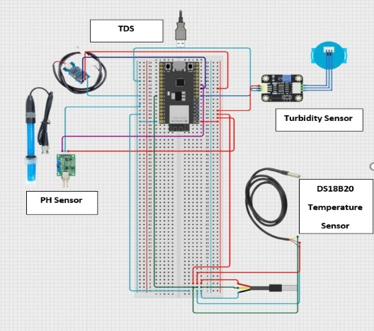

Figure 12‑: diagram of the hardware connection

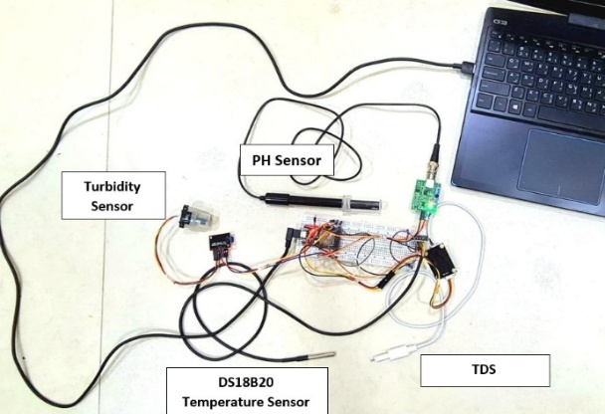

Figure 12‑: hardware connection

## Software Tools

This section describes the software tools that were used during the implementation:

* **Python:** Python played a central role in developing the machine learning model, processing sensor data, and building the backend server (using Flask). It was also used to interact with Firebase through service account credentials and integrate all system components.
* **Arduino IDE / Arduino Cloud:** The Arduino IDE was used to program the ESP32 microcontroller, enabling communication with sensors such as pH, TDS, turbidity, and temperature. It also handled Wi-Fi connectivity and data transmission to the Flask server.
* **Flask (Python Framework):** Flask was used to build a lightweight server hosted on Render.com. It received sensor data from the ESP32 via HTTP POST requests, processed it using a trained Support Vector Machine (SVM) model, and stored the classification results in Firebase.
* **Firebase Realtime Database**: Firebase served as the final cloud database solution. It was chosen for its real-time data handling capabilities, scalability, and ease of integration with Python. Classified water readings were stored under structured JSON paths for easy retrieval and display.
* **HTML & CSS:** These were used to design the front-end interface of the web application, allowing users to monitor classified water quality results stored in Firebase in a clean and user-friendly format.
* **Jupyter Notebook:** Jupyter Notebook was used to develop and train the SVM machine learning model. The training process included data preprocessing, feature scaling, model validation (via cross-validation), and model export in a serialized format for use in the Flask backend.

## **Commands and Code Snippets:**

### Wi-Fi Credential Storage in EEPROM

Figure 12-3: Wi-Fi Credential Storage in EEPROM code snippet

Figure 12-3 shows how to store the Wi-Fi SSID and password in EEPROM, so the user only needs to enter them once.

### Sensor's Measurement Functions

Figure12-4: Sensor readings code snippet

Figure 12-4 contains the code responsible for reading the raw data from the sensors. Each sensor has a dedicated function that collects and calibrates real-time readings from water samples.

### Sensor Data Packaging and Sending to Flask

Figure12-5: Data sending code snippet

This section includes the code that gathers sensor data into a JSON payload and sends it to the Flask server via HTTP POST every 30 seconds. as shown in figure 12-5.

### SVM

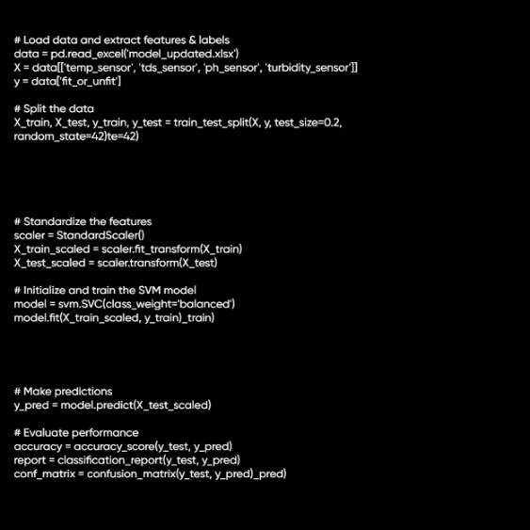

Figure 12‑6: SVM module code snippet

This section includes the code in figure 12-6 that handles the classification task using a Support Vector Machine (SVM). It starts by loading the preprocessed data, splitting it into training and testing sets, and standardizing the input features. After that, it initializes the SVM model with class balancing to handle possible data imbalance, trains the model on the training set, and finally evaluates it by predicting on the test set and printing accuracy, precision, recall, and the confusion matrix for performance analysis.

### Flask Server Endpoint to Receive and Classify Data

Figure -7: flask route code snippet

Figure 12-7 includes the code that defines a Flask route /classify that accepts data, processes it with a trained ML model, and returns classification.

### Storing Classified Results to Firebase

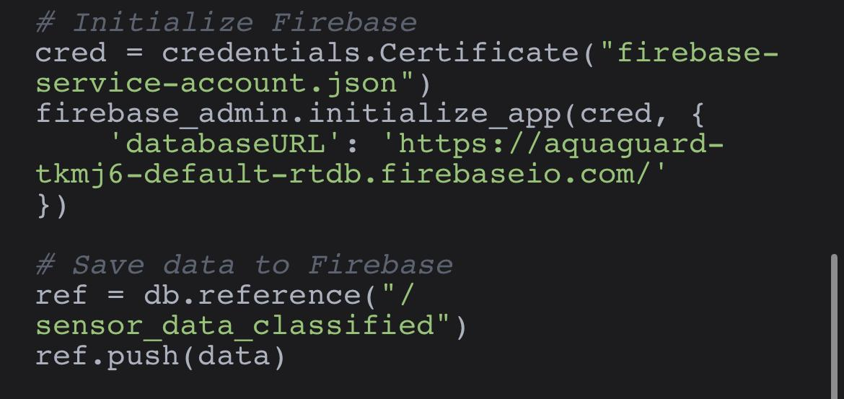

Figure12-8: Data storage to firebase code snippet

Figure 12-8 Pushes the classified water quality data along with a server timestamp into Firebase Realtime Database.

# Overall Project Outcomes/Achievements

This section presents the outcomes, results and outlines the website functionality, which processes water samples and displays results based on the predictions made by the models.

## Model Suitability

Based on the results and testing, the SVM model stands out as the most balanced and dependable option. It demonstrates high predictive power, robustness, and generalizability, making it the most appropriate choice for real-world deployment. Decision Tree and Random Forest, despite their initial high scores, are deemed unsuitable due to their overfitting tendencies. Logistic Regression, while not overfitting, lacks the precision required for critical classification tasks.

Overall, the **Support Vector Machine (SVM)** model proved to be the most reliable and effective for this project. It achieved **high accuracy** and, most importantly, recorded **zero false negatives**, ensuring that all unsafe water samples were correctly identified.

## Selection of Cloud Storage

One of the standout achievements of this project was the successful implementation of a fully cloud-based architecture that integrates IoT, machine learning, and real-time data storage hosted on a Flask server, and store the results in the cloud. By leveraging Firebase Realtime Database, the system achieved:

* Continuous and reliable data transmission from sensors.
* Instant and dynamic classification and centralized cloud storage of results.
* A scalable backend ready for future integration with dashboards, notifications.

This architecture reflects the best modern practices in deploying AI-driven IoT solutions and demonstrates the project’s readiness for real-world application in agricultural water quality monitoring

## Web Application Functionality

This is the web application interface of our project. The goal of the interface is to help the user navigate the system services with ease.

* **Home Page:**

This is the first page that the user will see when opening the web application see figure (13-1). The user can navigate to **monitor water quality:**

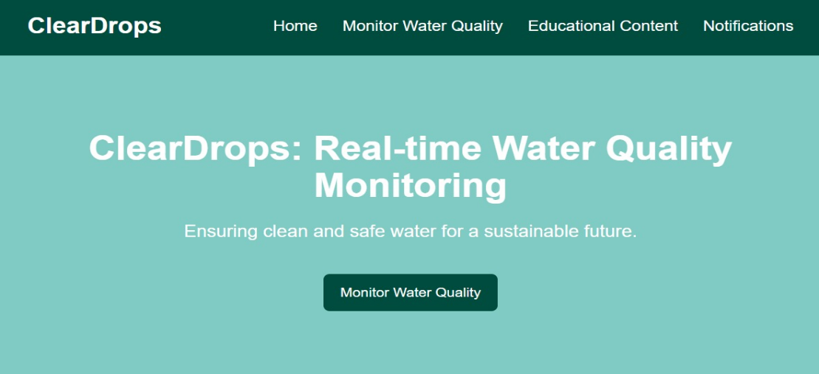

Figure 13‑1: Home page

* **Monitor Water Quality Page:** This page in figure 13-2 will show the sensors results, as well as a statement about water usability wither it is suitable or unsuitable for agricultural purposes with justification.

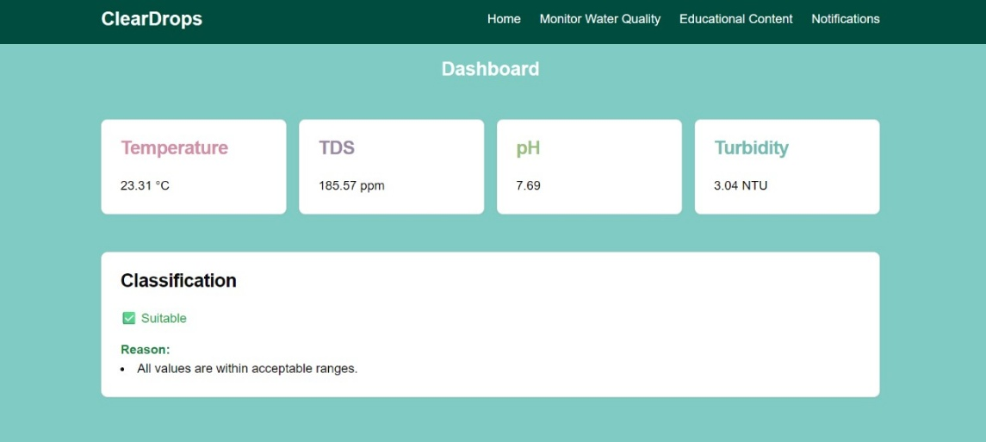

Figure ‑2: Monitor water quality page

* **Educational Content page:** this page is selected from the menu, and it shows explanations and instructions as you see in figure (13-3).

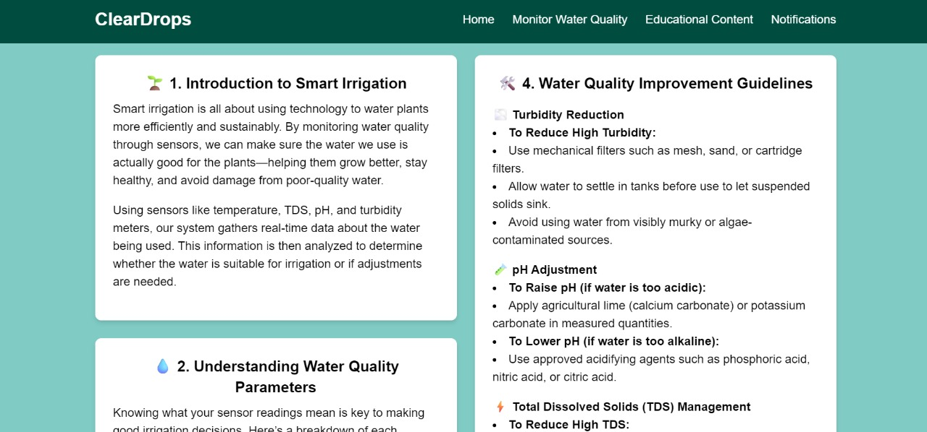

Figure 13‑3: Educational Content page

* **Notifications Page:** this page is selected from the menu and a form appears to fill in the data such as the e-mail to receive the notification as shown in figure (13-4).

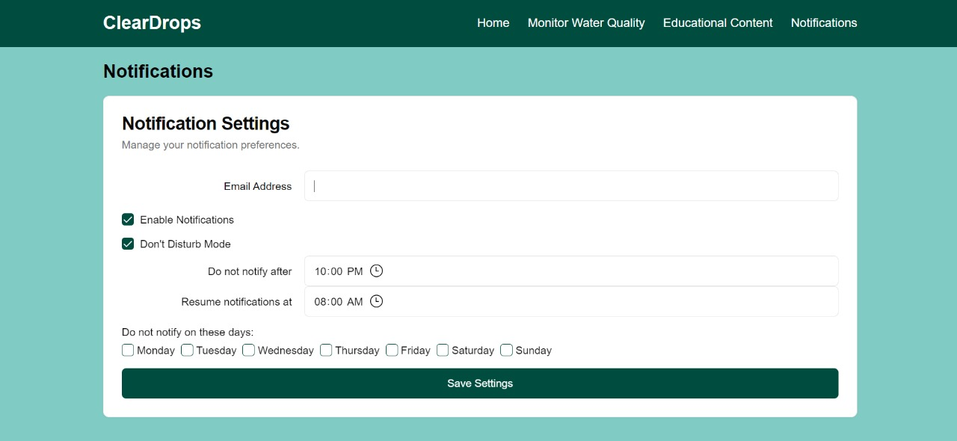

Figure ‎13‑4: Notification page

## Justification of Classification Outcomes:

In our system, classification of water samples is first performed by the trained Support Vector Machine (SVM) model, the model predicts whether the water is suitable (1) or unsuitable (0) for irrigation. After this classification, we use conditional (if-statement) logic to provide justification for the result as shown in figure 13-5. These justifications are only executed after the model finishes its classification.

* **If the sample is classified as unsuitable (0):**

The system enters a sequence of if statements to check which parameters fall outside the acceptable thresholds. It then provides the user with a specific explanation, such as “pH is outside the safe range (6.5-8.5)”. This helps users understand the reason for unsuitability and take corrective action.

* **If the sample is classified as suitable (1):**

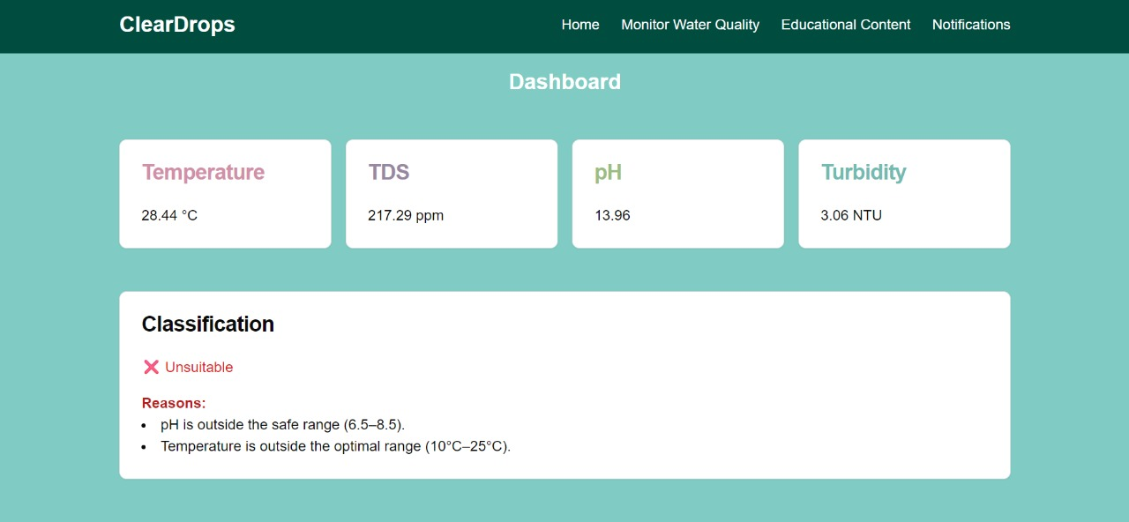The system confirms that all values are within the acceptable ranges and informs the user accordingly. This feedback reinforces confidence in the water’s quality for irrigation use. This approach helps users not only to see the result but to understand the rationale behind it in clear, actionable terms.

Figure 13‑5: Justification example

# Analysis of Overall Result Through Comparison, Validation or Verification

This section provides a detailed interpretation of the results presented in Section 14. It focuses on evaluating the performance of each machine learning model, identifying potential issues such as overfitting, and determining which model is best suited for deployment in a real-world setting, and test cases of the website functionality.

## Initial Evaluation and Overfitting Concerns

In the initial phase, the dataset consisted of 2,605 samples. The Decision Tree and Random Forest models achieved 100% accuracy on both training and testing sets. Although these results may seem ideal, such perfect performance often indicates overfitting, where the model memorizes training data rather than learning generalizable patterns. The SVM model showed 99% accuracy, which is still high but more realistic, suggesting better generalization with slight potential for overfitting. Logistic Regression achieved 89% accuracy, the lowest among all models, and showed limited ability in distinguishing between safe and unsafe water samples. These findings raised concerns about the reliability of some models in real-world scenarios, particularly in safety-critical contexts where accurate classification is essential.

## Dataset Expansion and Model Reevaluation

To mitigate overfitting and improve model performance, the dataset was expanded to 5,931 samples. This enhancement aimed to introduce more variability and improve the models’ ability to learn meaningful patterns rather than memorizing data.

After re-training and re-evaluating the models using the expanded dataset:

* The Random Forest model maintained 100% training accuracy and achieved 97% testing accuracy.
* The Decision Tree model also retained 100% training accuracy, but its testing accuracy decreased slightly to 95%, indicating a partial reduction in overfitting.
* The SVM model delivered consistent 97% accuracy across both training and testing phases, reflecting strong generalization and balanced performance.
* Logistic Regression showed a slight drop in performance, with 87% accuracy, and remained the least effective model.

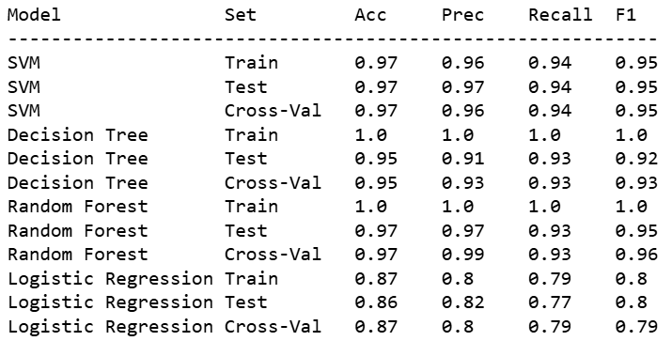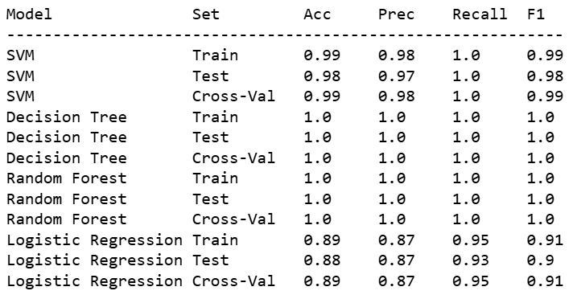These results show that expanding the dataset helped reduce overfitting for some models, especially Decision Tree and Random Forest, while confirming the consistent robustness of SVM. The following tables (‎14‑3)( ‎14‑1) summarize and compare the models’ performance before and after dataset enhancement:

Table ‑2: module comparison after expanding

Table ‑: module comparison before expanding

## Cross-Validation and Confusion Matrix Insights

To verify the generalizability of the models, k-fold cross-validation was conducted. The results confirmed that the Decision Tree and Random Forest models continued to perform perfectly across folds, reinforcing the likelihood of overfitting. These models also showed a number of false negatives in confusion matrix analysis, which poses a risk in safety-critical applications such as water quality assessment. In practical scenarios, particularly where safety is a concern, false negatives can have serious consequences. A model that fails to detect unsafe water poses a direct risk to crops and health. The SVM models only had 19 false negatives and consistent performance make it the most suitable candidate for integration into the system, ensuring reliable and safe classification of water quality. On the other hand, the SVM model achieved consistently strong results across all folds without signs of overfitting. It maintained high accuracy and achieved only 19 false negatives, indicating a strong ability to correctly detect unsafe water samples while minimizing false classifications.

## Confusion Matrix:

The confusion matrix is a crucial tool in evaluating the performance of a classification model. By analyzing the confusion matrix, we can gain insights into potential issues such as false positives or false negatives, which are important for understanding the strengths and weaknesses of the model.

|  |  |
| --- | --- |
| Figure 14‑1: SVM confusion matrix  Very strong performance.  Only 12 false positives, 19 false negatives.  Ideal when false negatives (unsafe water marked as safe) are too low. | 38 false positives, and 28 false negatives.  Figure 14‑: Decision tree confusion matrix  That means 28 unsafe water samples were incorrectly labeled as safe, not ideal for deployment. |
| 22 false negatives, and 5 false positives.  Figure 14‑: Random Forest confusion matrix  Still a concern for safety. | Most errors overall:  Figure 14‑: Logistic regression confusion matrix  72 false positives — mislabeling safe water as unsafe (inconvenient).  84 false negatives — mislabeling unsafe water as safe (risky).  Indicates poor separation between classes. |

Table ‎14‑5: Confusion matrix for multiple modules comparaison

The confusion matrices offer deeper insight into the behavior of each model beyond accuracy metrics. The **SVM model** stands out, with **19 false negatives** and minimal false positives, making it ideal for the project. In contrast, **Decision Tree** and **Random Forest** models, while achieving high accuracy. **Logistic Regression**, with significantly more misclassifications, is considered the least reliable in this context.

## Cloud Storage and System Optimization

To determine the most effective method for storing classified sensor data, two cloud-based storage approaches were implemented and evaluated: **MySQL** via phpMyAdmin and **Firebase** Realtime Database. Each method was tested in a working version of the system, allowing for a practical comparison based on performance, integration complexity, scalability, and suitability for IoT-based data flows.

The table below summarizes the key differences:

|  |  |  |
| --- | --- | --- |
| Feature/Aspects | MySQL (phpMyAdmin) | Firebase Realtime Database |
| Integration with Flask Server | Required setting up SQL connections and queries | Simple integration using Python Firebase libraries |
| Setup and Configuration | Manual setup of database tables and schema | Quick JSON-based setup |
| Data Format | Structured tables (rows and columns) | JSON tree structure |
| Real-Time Data Handling | Not real-time — needs manual refreshing or polling | Built-in real-time synchronization |
| Cloud Hosting Requirements | Requires managing a hosting service | Fully managed by Google |
| Latency | Higher — SQL query processing adds overhead | Lower — data is saved instantly by Flask |
| Suitability for IoT | Limited flexibility | Excellent for IoT and website integration |

Table ‎14‑6:cloud storage comparison

After testing both methods, Firebase Realtime Database was selected as the final solution due to its faster performance, real-time updates, and simpler integration with the Flask server. Its flexibility and scalability made it a more suitable choice for an IoT-based system like this, where sensor data is continuously collected, classified, and stored in the cloud.

## Website Testing Results

To test the website functionality, different samples of water were collected and then the sensors were connected. The website showed the following results in response to various samples:

1. **Suitable water:**

|  |  |
| --- | --- |
| **Test case #1** | |
| **Test case ID: 1** | |
| **Test Priority (Low/Medium/High):** High | **Final Result:** Success |
| Test Title: Water quality classification with suitable sample | |
| **Description:** The system receives real-time data from sensors (pH, turbidity, temperature, TDS), classifies the sample as suitable using the SVM model, and displays the result properly | |
| **Pre-conditions:** Water sample must meet irrigation standards | |
| **Post-conditions:** The website shows classification as “Suitable”, and displays all sensor values correctly | |

Table ‑: Test case1

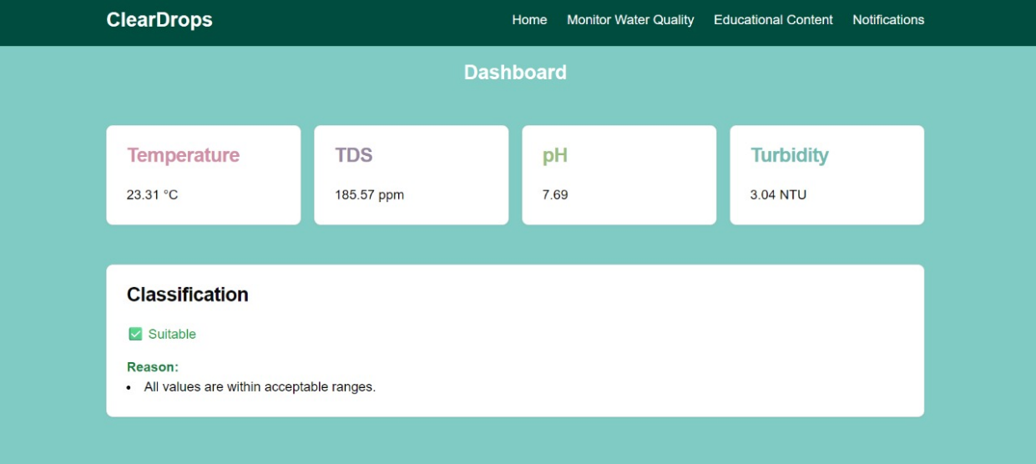

Figure ‑5: suitable water with acceptable parameters

1. **High pH:**

|  |  |
| --- | --- |
| **Test case #2** | |
| **Test case ID: 2** | |
| **Test Priority (Low/Medium/High):** High | **Final Result:** Success |
| **Test Title:** Water quality classification with unsuitable sample | |
| **Description:** The system receives real-time data from sensors that exceed safe limits (pH > 8.5), and classifies the water as unsuitable | |
| **Pre-conditions:** sample water must exceed at least one parameter threshold | |
| **Post-conditions:** Website displays “Unsuitable” classification with the readings provided and reason | |

Table ‑: Test case 2

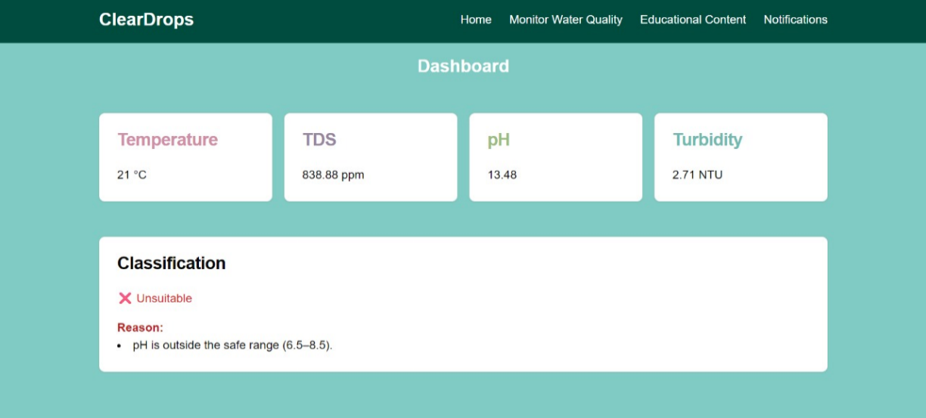

Figure ‑6: High pH resulting to classify it as unsuitable

1. **High TDS:**

|  |  |
| --- | --- |
| **Test case #3** | |
| **Test case ID: 3** | |
| **Test Priority (Low/Medium/High):** High | **Final Result:** Success |
| **Test Title:** Water quality classification with unsuitable sample | |
| **Description:** The system receives real-time data from sensors that exceed safe limits (TDS >1000 mg/L), and classifies the water as unsuitable | |
| **Pre-conditions:** sample water must exceed at least one parameter threshold | |
| **Post-conditions:** Website displays “Unsuitable” classification with the readings provided and reason | |

Table ‑: Test case 3

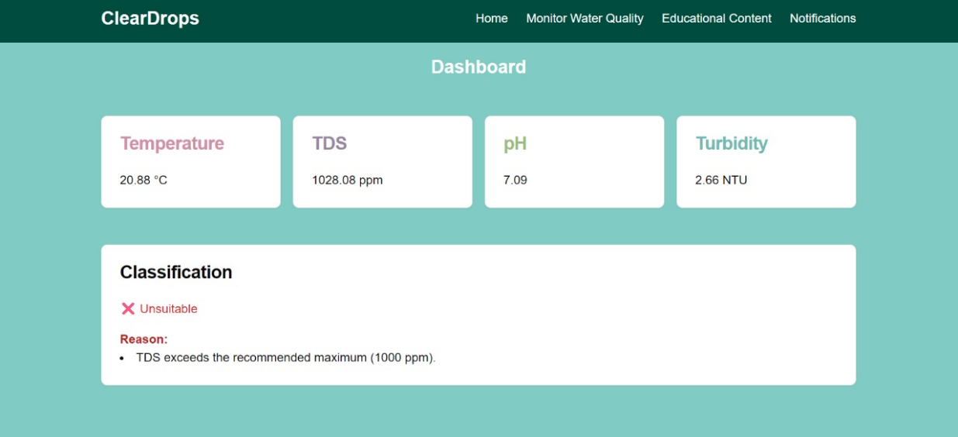

Figure -7: TDS resulting in classifying it as unsuitable

# Comprehensive Remarks on Overall Project Outcomes and Achievements

Data collection combined with testing reveals encouraging results about employing AC condensate water as an irrigation source for agricultural purposes. Sensor readings indicate that the water aligns with irrigation standards. The predictive analytics and real-time monitoring features of the system have demonstrated effectiveness in detecting water quality fluctuations and issuing alerts accordingly. Experiments show machine learning algorithms perform accurately to forecast water quality patterns. Overall, these findings validate the project's core objectives and set the stage for further enhancements in its implementation. Finally, we successfully completed our project as planned.

## Conclusion

The "Reusing Air Conditioning Water for Agriculture" project offers an environmentally friendly solution to water shortages in dry areas through the recycling of air conditioner condensate water for agricultural purposes. The system uses smart sensors together with machine learning algorithms to verify water quality before its utilization, in line with established quality standards. The project enhances sustainable water management while contributing to greener urban development and improving agricultural operational efficiency. Using predictive analytics and real-time monitoring in this system helps optimize resource use in areas with limited water supplies and supports environmental preservation initiatives. It is recommended that policymakers and urban planners adopt this system in arid regions to enhance water reuse practices and promote sustainable agriculture. The implementation of this project reinforces the importance of innovative technology in addressing global environmental challenges and ensuring a greener future.

## Future Work

While the current project proves that recycling reusing air conditioning condensate water can be used for farming irrigation, several areas offer potential for further development:

1. **Advanced Filtration and Purification Technologies:** Future iterations of the system could include multi-stage filtration systems such as activated carbon and UV sterilization to improve water quality and comply with the agricultural safety standards for a broader range of crops.
2. **Smart Automation and IoT Expansion:** The potential to expand use of IoT to enable automated irrigation scheduling based on real time measurements of soil moisture and weather conditions. It would improve water efficiency and crop yield.
3. **Integration with Renewable Energy Sources:** The system can further support sustainability by using power generated by solar energy where there is high solar intensity, as in the Gulf region. This would make the solution less dependent on the electrical grid and make it more eco-friendly.
4. **Collaboration with Government and Non-governmental organization:** Partnerships with environmental and agricultural bodies can lead to pilot programs in arid regions, enabling large-scale testing and generating data for policy development on sustainable water reuse.
5. **Environmental and Economic Impact Assessment**: Conducting comprehensive life-cycle assessments and cost-benefit analyses will help validate the project's viability and inform stakeholders about its long-term implications.
6. **Pilot Programs and Field Testing**: Conducting long-term field tests in various climatic and agricultural environments will help validate the system's performance and allow for refinement based on real-world feedback.
7. **Automated Nutrient Dosing**: Integrating a nutrient management system can allow for the automated addition of essential fertilizers based on crop requirements and water characteristics, turning the system into a smart fertigation solution.

# References

[1] Crouch, M. L., Jacobs, H. E., & Speight, V. L. (2021). Defining domestic water consumption based on personal water use activities. AQUA — Water Infrastructure, Ecosystems and Society, 70(7), 1002. <https://doi.org/10.2166/aqua.2021.056>

[2] Moossa, B., Trivedi, P., Saleem, H., & Zaidi, S. J. (2022). Desalination in the GCC countries - a review. Journal of Cleaner Production, 357, 131717. <https://doi.org/10.1016/j.jclepro.2022.131717>

[3] Konde, S., & Deosarkar, S. B. (2020). *IOT Based Water Quality Monitoring System*. International Conference on Communication and Information Processing (ICCIP-2020). SSRN. <https://ssrn.com/abstract=3645467>.

[4] Zainurin, S.N., Ismail, W.Z.W., Mahamud, S.N.I., Ismail, I., Jamaludin, J., & Ab. Aziz, N.A. (2023). Integration of Sensing Framework with a Decision Support System for Monitoring Water Quality in Agriculture. *Agriculture*, 13(5), 1000. <https://doi.org/10.3390/agriculture13051000>.

[5] Matarneh, S., AlQaraleh, L., Alkhrissat, T., & Abdel-Jaber, M. (2024).

Assessing water production from air conditioning systems as an unconventional supply source: A focus on water quality and social acceptance perspectives. *Case Studies in Chemical and Environmental Engineering, 9*, 100585. <https://doi.org/10.1016/j.cscee.2023.100585>

[6] Abdullah, M. A., & Mursalin, R. (2021). Condensed water recycling in an air conditioning unit. *IOSR Journal of Mechanical and Civil Engineering (IOSR-JMCE)*, 18(3), 13–19. <http://dx.doi.org/10.9790/1684-1803021319>

[7] AlGhamdi, M., Jamjoom, R., Bazuhair, M., & Alhoshan, M. (2024). Heavy metals and microbial assessment of air conditioning condensate water in Jeddah City-Saudi Arabia: Concept of sustainable water resources. Environmental Research and Development. <https://doi.org/10.1007/s40899-024-01122-2>

[8] Siam, L., Al-Khatib, I. A., Anayah, F., Jodeh, S., Hanbali, G., Khalaf, B., & Deghles, A. (2019). Developing a strategy to recover condensate water from air conditioners in Palestine. *Water, 11*(8), Article 1696. <https://doi.org/10.3390/w11081696>

[9] Seeed Studio. (2024). Grove - PH sensor kit (E-201C-Blue) [Image]. Retrieved October 19, 2024, from <https://wiki.seeedstudio.com/Grove-PH-Sensor-kit/>

[10] Keyestudio. (2021). [Image of the keyestudio TDS Meter V1.0] [Image]. Retrieved October 19, 2024, from <https://wiki.keyestudio.com/KS0429_keyestudio_TDS_Meter_V1.0>

[11] Innovators Guru. (2020). [Image of the TS-300B Arduino turbidity sensor] [Image]. Retrieved October 19, 2024, from <https://innovatorsguru.com/ts-300b-arduino-turbidity-sensor/>

[12] Maker Advisor. (2024). [Image of the DS18B20 Digital Temperature Sensor] [Image]. Retrieved October 19, 2024, from <https://makeradvisor.com/tools/ds18b20-digital-temperature-sensor/>

[13] Ayers, R. S., & Westcot, D. W**.** (n.d.). *Water quality for agriculture* (FAO Irrigation and Drainage Paper No. 29 Rev. 1). Food and Agriculture Organization of the United Nations. <https://www.fao.org/4/t0234e/t0234e00.htm>

[14] Shoushtarian, F., & Negahban-Azar, M. (2020). Worldwide regulations and guidelines for agricultural water reuse: A critical review. *Water, 12*(4), 971. <https://doi.org/10.3390/w12040971>

appendix A

Survey Results Summary

To better understand the level of public awareness and acceptance regarding the reuse of air conditioning condensate water for agriculture, a structured survey was distributed. A total of 50 participants responded, representing diverse age groups, educational backgrounds, and opinions. The results are summarized below:

**Demographic Overview**

* **Age Group:** Most participants were between **18–25 years old**, followed by respondents in the **Under 18** and **36–50** brackets.
* **Gender Distribution:** The majority of respondents identified as **female**.
* A colorful graph with text

  AI-generated content may be incorrect.**Education Level:** Most participants held a **Bachelor’s Degree**, with others having completed **High School**.

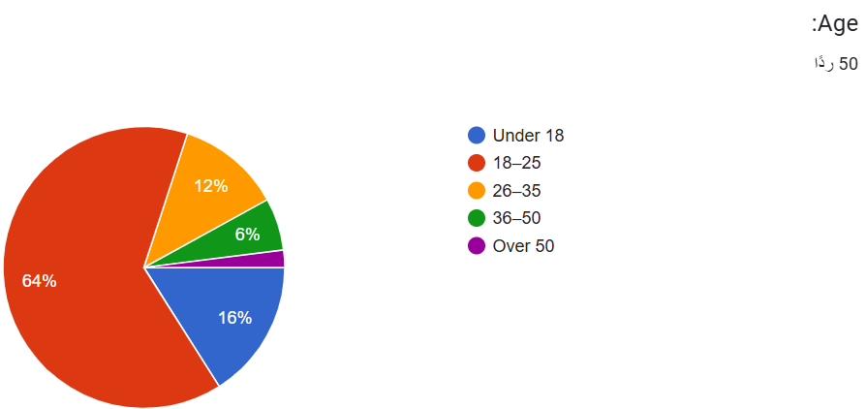

Figure 38: Education Level

Figure 37: Gender Distribution

Figure 36: Age Group

**Awareness and Attitude**

* **Awareness:** Over **95%** of respondents were aware that air conditioners produce water that is typically discarded.
* **Support for Reuse:** A significant majority (over **90%**) believed that reusing this water for agriculture is a good idea, showing strong public support for the project.

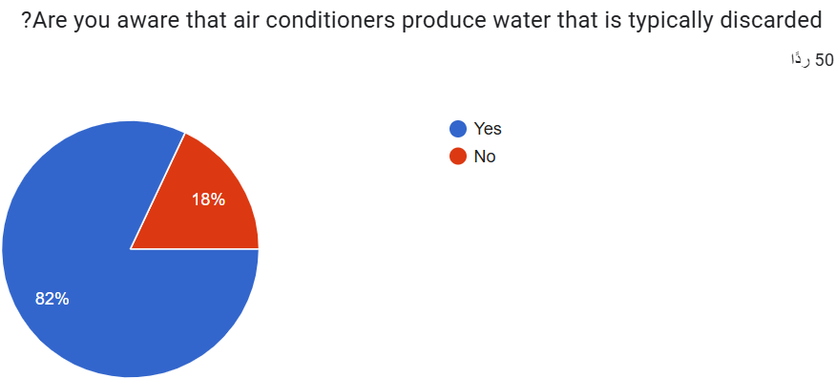

Figure 40:AC water for irrigation

Figure 39:AC water discarded

**Concerns About Reuse**

Respondents highlighted several concerns:

* **Water safety/quality** and **health risks** were the most common concerns.
* **Lack of awareness** was also mentioned frequently.
* A smaller group cited **cost and system complexity** as potential barriers.

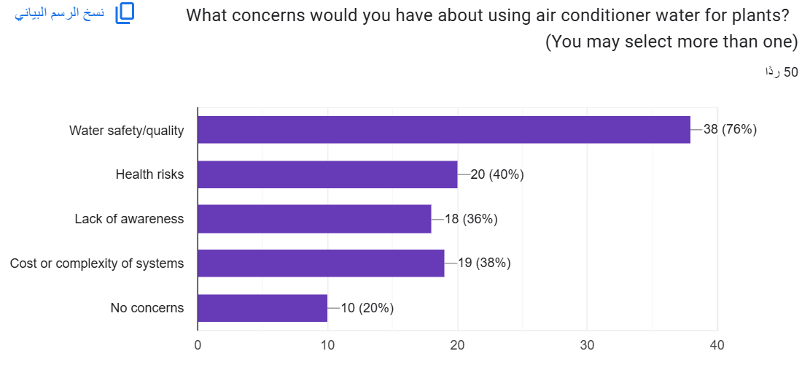

Figure 41 : AC reuse concerns

**Adoption Potential**

* Almost all participants (**~96%**) stated they would consider using a device that collects and evaluates air conditioner water for irrigation.

Figure 42: Consider using the system

**Trust and System Features**

* A majority expressed **trust** in the system’s ability to assess water quality.
* When asked what features would boost their confidence:
  + **Clear results and explanations** was the most selected feature.
  + Some also preferred **expert/government endorsement** and **automatic treatment options**.

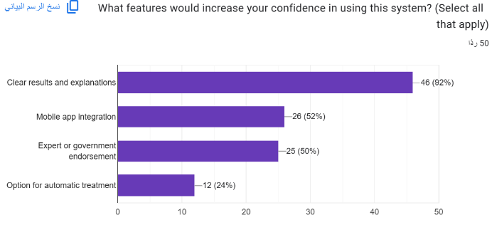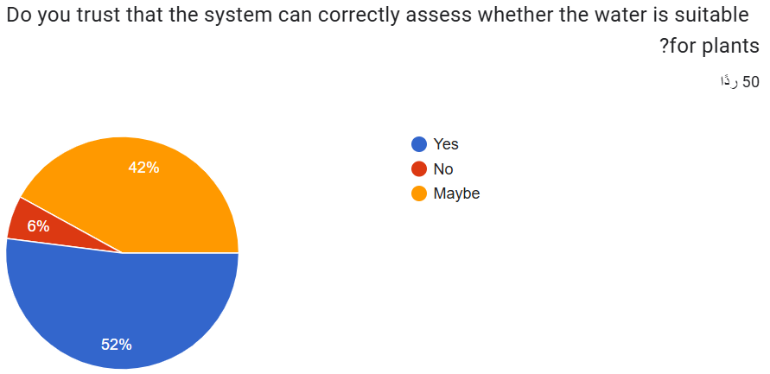

Figure 44: increase confidence

Figure 43: Trust the system